2022-6-2

POLYHACK 2022 Project Report

MediTracker (Blockchain Question 01)

YANG Yuebo (Wilbur) XIE Qichen (Shane) XU Jiaying (Karry)

The Hong Kong Polytechnic University

**POLYHACK 2022 Project Report**

**MediTracker**

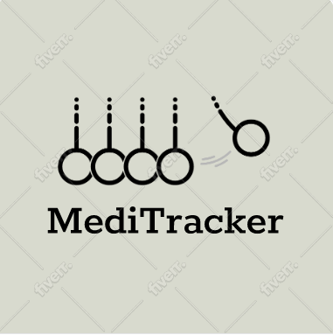

(The logo of MediTracker)

<https://youtu.be/2eJOpfna3gM>

<https://20074925d.wixsite.com/meditracker>

<https://github.com/wilbur20074925d/MediTrack-PolyHacker>

Xie Qichen (Shane)

XU Jiaying (Karry)

YANG Yuebo (Wilbur)

**CONTENTS**

1. Background 3

1.1 Blockchain 3

1.2. Need of blockchain in healthcare 4

1.3. Medicine transparency 5

2. Problem Explanation 5

3. Proposed Solution 6

3.1 Solution of Blockchain 6

3.2 Policy considerations for deploying blockchain 8

3.3 Build up the Medi Tracker System 10

4. Business Model 11

5. Underlying Technology 12

5.1 Usage of technology 12

5.2 Implementation of the Medicare Project 12

6. Market and Competition 33

6.1 Few Blockchain Implementation 33

6.2 Restraint: Reluctance to disclose data 34

6.3 Opportunity: Government Initiatives (Smart City) 34

6.4 Challenge: Lack of awareness & understanding 35

7. Team 35

8. Projections and Milestones 36

9. Status and Milestones 39

10. Summary and Call to Action 45

10.1 Future limits and call to action 45

10.2 Conclusion 45

# Background

## 1.1 Blockchain

Blockchain is a decentralized network of nodes that store data. This is a great technology to protect confidential data in the system. This technology makes it possible for you to exchange important data and keep it safe and secure. It is a perfect tool to keep all related documents in one place and safe. Blockchain also speeds up the search for candidates that meet specific testing criteria by using a unique patient database. The Blockchain can be described as a decentralized peer to peer (P2P) network of personal computers called nodes, which maintains, stores, and records historical or transaction data. It allows a reliable collaboration as the information is stored and exchanged by all network members and keeps a constant track of past and current experiences. This technology can integrate disparate networks to provide insights into the importance of individual treatment. Thus, Blockchain can well be recognized for immutability and safety. Blocks, nodes, and miners are the three main ideas in Blockchain. Blockchain does not store any of its data in one place. Instead, a network of computers copies and propagates the Blockchain. Every computer on the web updates its Blockchain to reflect a new block in the Blockchain. Figure 1 shows the basic working steps of Blockchain technology.

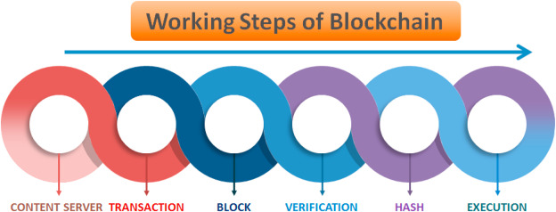

A Blockchain system that operates on the Internet, on a P2P network of computers that all run the protocol and have an identical copy of the transaction ledger, allowing valuable P2P transactions without the use of a central computer. consensus period. There are diverse types of Blockchain technology such as public, private, hybrid or consortium. Each Blockchain network has different advantages and disadvantages, which affect its optimal applications.

Blockchain can be a major alter from conventional approaches to data management. In a conventional database, the information is held in a single, central server (or server arrange) with a centralized database chair. In differentiate, blockchain is an approach to overseeing information where they are appended on an electronic record that is dispersed over a peer-to-peer arrange with no central organization of the information.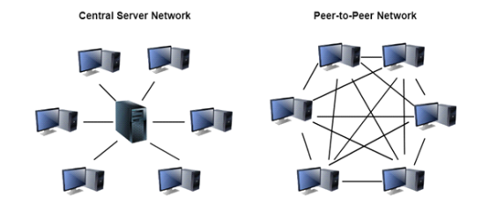

Figure 1. Centralized versus a distributed, peer-to-peer network.

In a blockchain, information such as a deals exchange record or a therapeutic record are put away in squares. When the information to total a square have been entered, the square is included to the chain of past squares and a new piece is made for the following information section. Blockchains are decentralized and can have an unlimited number of members in a arrange, such as a worldwide arrange of merchants and buyers of medical equipment. All members in a blockchain have a full duplicate of the blockchain, which is persistently updated and synchronized as unused pieces are included. A hub could be a computer/device that stores or gives access to a duplicate of the blockchain. All the records in a blockchain are obvious to all the members within the blockchain network

## 1.2. Need of blockchain in healthcare

As far as healthcare is concerned, the urgency of development increases to more incredible speeds. Today the need is for quality health facilities supported by advanced and newer technologies. Here, Blockchain would play a critical role in transforming the healthcare sector. In addition, the landscape of the health system is moving towards a patientcare approach focusing on two main aspects: accessible services and appropriate healthcare resources always. The Blockchain enhances healthcare organizations to provide adequate patient care and high-quality health facilities. The exchange of medical information is another time-consuming and repetitive process leading to prohibitive costs for the medical industry, which is quickly resolved using this technology. Through Blockchain technology, citizens can participate in health education programs. In addition, better research and shared data on the public welfare will improve treatment for different communities. Centralized database used to manage entire healthcare systems and organizations.

## 1.3. Medicine transparency

In today’s healthcare space, the conversation around transparency is consumer centric. Consumers have the right to inquire about treatment options and costs, potential treatment risks, realistic outcomes, and more. Healthcare providers must respond with as much information as possible to ensure appropriate care is provided, quality and safety are a priority, and that patients and their care teams can make thoughtful care decisions.

# Problem Explanation

The issue of transparency in the drug delivery chain is one that has been of great concern to the government in recent years. This is because when there is a problem with a drug, the chain of transmission is an effective way to find out where the problem occurs.

The public accounting method of blockchain makes it possible to trace products back to the stage of raw materials used. On the blockchain, the bookkeeping right does not belong to any one person, which also eliminates the possibility of manipulating data according to personal interests. In addition, the asymmetric encryption technology of blockchain can ensure the security of data. When people buy medicine when they are sick, people sometimes worry about buying incorrect and nonstandard drugs, or some unscrupulous doctors prescribe fake drugs for the benefit of patients or exaggerate the price to earn the patient's hard-earned money. Therefore, we need to track the source of drugs, such as which hospital or drugstore sold them, or even the manufacturer of drugs. The blockchain technology is used to record the entire process of the production, circulation, and use of various drugs, which ensure that all nodes are traceable, and realize the entire process visual supervision. Parties can obtain the information of products in each circulation link through the blockchain. The complete drug information is open, transparent, and traceable, and the transaction records cannot be tampered with. Therefore, it also monitors the medical ethics displayed by doctors when they sell drugs to help patients' health.

# Proposed Solution

We combine the drug delivery chain with blockchain. Based on blockchain's traceability and tamper-evident nature, we can improve the transparency of drug delivery chain.

Indeed, some time recently the rise of COVID-19, the healthcare and life sciences businesses confronted noteworthy issues, counting interoperability, protection, and supply chain traceability. Another major challenge is that restrictive, electronic wellbeing record frameworks — from more than 700 merchants — routinely don’t conversation to each other.¹ And within the U.S. alone, we saw 1,750 occurrences of medicate falsifying in 2018.² As the widespread proceeds, healthcare and the life sciences confront modern challenges, counting adjusting supply chains to convey defensive hardware and quickly creating medicines, tests and antibodies. In the interim, healthcare experts are hooking with how to oversee assent and keep person wellbeing information secure as they see to use wellbeing information to securely re-open for business. Blockchain has as of now illustrated its esteem in healthcare and the life sciences by empowering believe and collaboration and will proceed to be at the forefront of tending to ever more challenges.

## 3.1 Solution of Blockchain

Blockchain technology brings credibility and findings to clinical trials. Those records can be stored in the digital thumbprint as intelligent contracts on the Blockchain. Network infrastructure security at all levels, identity verification and authentication of all participants, and uniform patterns of authorization to access electronic health information are only a few of the benefits of Blockchain Technologies in Healthcare. A Blockchain is used to maintain the monitoring of the pharmaceutical supply chain and tracking of medication responsibilities. This technology is applicable for storing the information of even an individual patient and, therefore, helps analyses and validate the effects of a particular procedure. Blockchain is used for health record storage, clinical trials, patient tracking, improved security, information visibility, and transparency. It maintains financial records in the hospital and minimizes data conversion time and costs.

In a data-centric environment, it solves several problems. Blockchain technology will generate a hash for individual patient health record blocks. The Blockchain system will also incentivize patients to expose their required data to third parties while keeping their identities secret. A large data set is needed to conduct a clinical trial. Researchers focus on these data sets and perform experiments regularly to provide analyzes, estimates, and effectiveness rates under different circumstances. Data is analyzed and other decisions are made based on these results. However, many scientists can manipulate the data and evidence gathered to change the results.

In addition, many drug manufacturers want to subscribe to discoveries that will provide their companies with such benefits. As a result, researchers are using Blockchain technology to make clinical studies fairer and simpler. This will make signing up for clinical trials safe, unequal, and simple. The insights gathered can improve patient treatment and provide post-marketing analysis to optimize effectiveness benefits. These standards are rooted in important aspects of Blockchain technology such as open management, transparent audit guidelines, transparency, robustness of data, and improved privacy and security. This allows healthcare providers to meet applicable healthcare standards, including the security of pharmaceutical supplies.

Precise and unquestionable distinguishing proof of people (e.g., patients and suppliers) as well as organizations (e.g., clinics, drug stores, the scholarly world and other inquire about teach) is crucial to great outcomes in the wellbeing segment. A blockchain can include astuteness and straightforwardness and combat differential versioning of identities, in this way empowering secure recognizable proof. This will end up progressively vital as more information begin to stream from wearable therapeutic gadgets and the Web of Things (IoT) so that this information is, for example, matched precisely with individuals’ electronic restorative records.

Wellbeing care suppliers – both person and hierarchical – must give precise and up-to-date information on their area and benefit accessibility to empower, for case, patients to find them; accrediting offices recognize them; and payers to repay them precisely. A blockchain may improve the veracity and precision of the significant data.

A blockchain can make an unchanging log of each time an information record is gotten to or revised. Estonia utilizes an application of blockchain innovation called KSI to secure government information, counting electronic health records, from outside cyber-attacks and from inner abuse. The KSI innovation gives security without damaging information security (e-Estonia, 2020). Any revision to a record can be crosschecked with partitioned electronic logs. Suspicious get to can be confirmed rapidly, and noxious, systemic action anticipated. Like CCTV in tall crime-risk areas, the blockchain does not intercede when a transgression happens. Or the perceivability (straightforwardness) and failure to hinder or revise the flag of the recording (permanence) may be an obstruction.

Outstandingly, the value-based impression of these informational, which contains as it were a catalogue of wellbeing records and metadata, is little compared to the real wellbeing data that are put away off-chain (Vazirani, 2019). This highlights how, as with most advanced developments, blockchain is most valuable when it is connected in combination with other advances inside a wellbeing data framework.

## 3.2 Policy considerations for deploying blockchain

Hypothetical and down to earth utilize cases recommend that blockchain may include esteem to the advanced change of health frameworks, especially within the ranges of personality confirmation, persistent assent and information sharing and get to consents, and therapeutic and pharmaceutical supply chain administration. In any case, to attain arrangement objectives it ought to be conveyed in combination with other advances and a vigorous wellbeing data framework and information framework which, working together, give the ideal arrangement to meet wellbeing data needs.

Buildup encompasses the potential of blockchain innovation within the wellbeing segment and its convenience can be overstated. Blockchain does not expel the foremost challenging impediments to the computerized change of the health division, such as a need of information interoperability, and it does not replace the require for wellbeing data governance. While blockchains do not require a central specialist to hold information, they do not remove the require for any authority at all. Given the nature of the wellbeing segment which its information is frequently individual and sensitive, blockchain applications will rely on control and oversight as well as measures and conventions. The consensus framework for administering any blockchain is not based on innovation but requires an agreement among members.

With numerous on-screen characters and members, a trusted body to create the rules (or, more precisely, the ‘rules that set the rules’) will continuously be required. This may be the government, or a built-up office or institution. For illustration, Standards Australia driven the advancement of a street outline of needs to assist build up common terminology for blockchain-enabled innovations

The taken a toll of improvement and execution of advances may be a key thought for arrangement makers. Evidence from Estonia, where blockchain innovation has been conveyed within the national wellbeing system, suggests that the coordinate costs in terms of specialized improvement and execution are humble. Once the core engineering is created, extra applications may be included at a lower fetched. As with any technological move, most costs are caused to alter forms, workflows, and practices to ensure that the innovation will be utilized as imagined. Of course, operational costs will depend on the efficiency of the blockchain plan and minimization of the volume of information put away ‘on chain.’

Blockchain speaks to a noteworthy flight from the conventional idea of information administration and storage and partner communication is exceptionally vital for the effective sending of the innovation. Training and instruction of the wellbeing workforce would be required to guarantee its successful and productive utilize. When the technology is conveyed to empower patients to have more prominent control over and get to their information, successful implementation will depend on open meeting and data to teach patients on how to get to the technology and their rights and obligations

The unchanging nature of blockchains can be a doubled-edged sword. Because it stands, the metadata put away on a blockchain that relates to an individual’s wellbeing record cannot be deleted. Whereas data put away off chain can be erased, the record that the data already existed cannot be evacuated from the chain. This data can be touchy, and a lawful address emerges whether the metadata tallies as personal health data (Panel for end Of the of Science and Innovation, 2019). The field is quickly evolving and mechanical arrangements to address this issue may be found, such as veiling squares associated with an indicated signature.

Whereas blockchain-based records are intrinsically secure and tamper-proof in terms of the information they contain, this does not guarantee that the information entered are rectify or of adequate quality. In expansion to client blunder, there is moreover potential for noxious on-screen characters to impact individuals’ decision-making with respect to assent and permissions to utilize their information. This chance is especially vital inside maturing populaces with growing numbers of individuals who are physically and cognitively helpless. Blockchain cannot oversee this hazard; only governance, direction and authorization have the permission.

Four standards ought to help arrangement creators with actualizing blockchain innovation in health.

1. Fit-for-purpose. Blockchain is an empowering, general-purpose advanced innovation. It ought to be evaluated on its merits and connected where it is the finest application for the issue at hand, after comparing it to elective solutions.
2. Administration and administrative arrangement. Blockchain-based arrangements have specific highlights that must be assessed in terms of the compliance of the arrangement with laws, directions, and data governance systems.
3. Incremental integration. Blockchain-enabled arrangements ought to be considered in connection to existing systems and innovations. Blockchain ought to complement and use existing frameworks and be tested incrementally in a controlled environment some time recently large-scale implementation.
4. Instruction, mindfulness, and user-based plan. Blockchain requires a better approach of considering about data and data. Clients of this innovation, counting patients and the open, must be educated regarding the highlights of this innovation and the suggestions of it utilize for information proprietorship, access, and privacy.

## 3.3 Build up the Medi Tracker System

Why is this so useful?

MediTracker has potential to offer innovative solutions because it has the related advantages:

* Consistent: With blockchain, information cannot vary over databases since there is one single record. This decreases issues with copy or altered data and makes the information itself much more open, instead of catching it in numerous organizations’ record-keeping systems.
* Append–only: Users can as it were included exchanges to a database, making everything traceable and auditable.
* Ownable: A substance can “own” information and select who gets to get to it. Rather than a company offering someone’s information to a third party, that individual can control where their information goes.
* Clear rules: One version of the database is utilized, and the rules it is known. (The need of information measures and master records in healthcare has made fracture and dissatisfaction over the industry.)
* Decentralized: Duplicates of the database are kept in numerous places and no third-party must exist as a director. This decreases overhead and the require for brokers (which healthcare has in spades). This moreover anticipates centralized frameworks from becoming totally bolted down and blocked off.

These qualities are awesome for teach or patients taking care of wellbeing data. Blockchain makes information keenness harder to alter with and less demanding to share between parties is less demanding. There are moreover numerous cybersecurity benefits, counting traceability and the capacity to confirm who has gotten to certain data.

# Business Model

Here is our implementation overview:

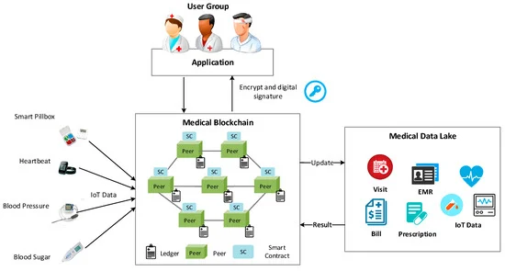

The SWOT Business Model of MediTracker

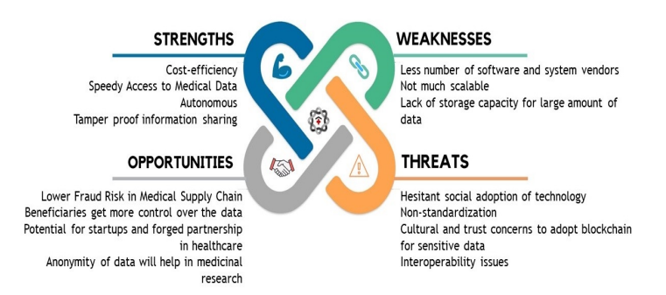

|  |  |
| --- | --- |
| **Page System** | **Target User** |
| Manufacture | Drug manufacturer |
| Certifying Client | Drug transfer |
| Hospital | Hospital staff |

# Underlying Technology

## 5.1 Usage of technology

Docker, Hyper Ledger, Rethink Database

Programming Language used: Java, Node.js, npm, CSS, python, html

Running alongside the core components from Hyperledger Sawtooth, Supply Chain includes a number of elements customizing the blockchain and user interaction with it:

* a transaction processor which handles Supply Chain transaction logic
* a server which provides an HTTP/JSON API for Supply Chain actions
* a ledger sync which synchronizes blockchain data to a local database
* a shell container with the dependencies to run any commands and scripts

## 5.2 Implementation of the Medicare Project

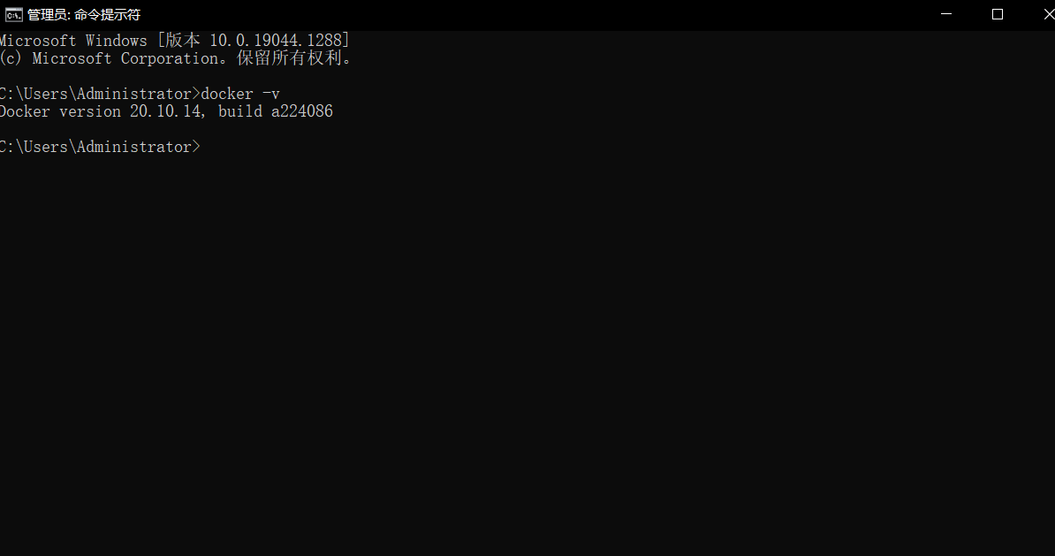

check the version of Docker, if you do not install docker, please install it.

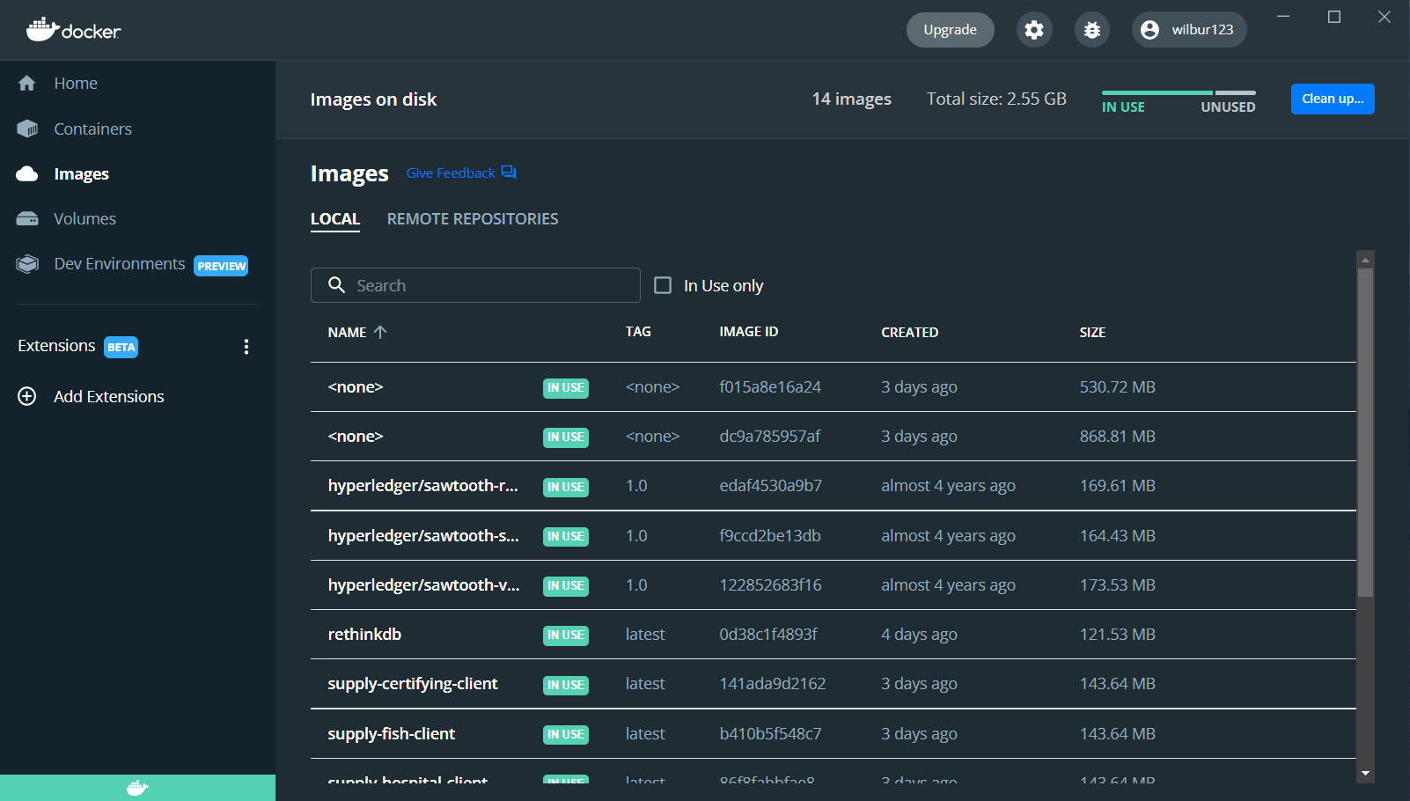

Open your docker and check the images of the MediTracker

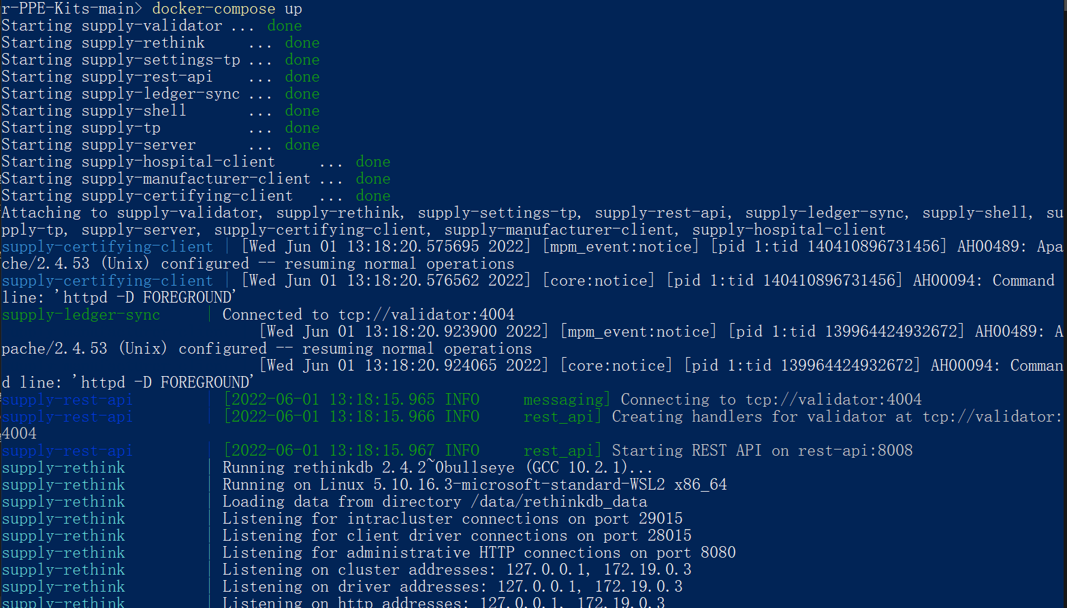

turn on the shell script and run as administer, enter the code: dockers-compose up and wait for the system to run.

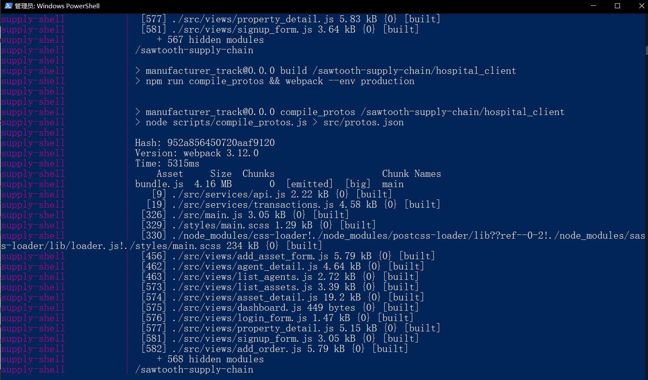

If there is no warning, it means it works well.

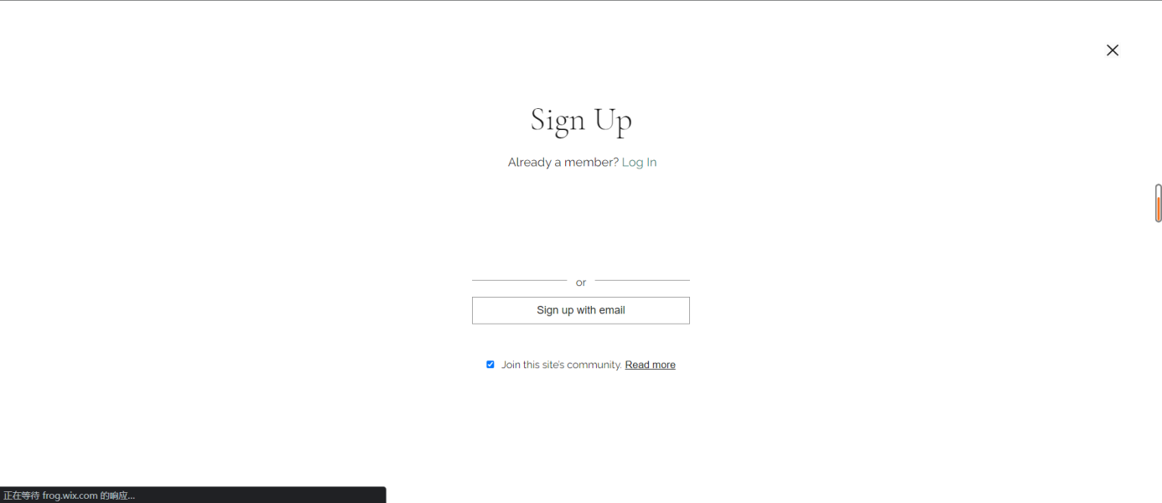

Now turn on the Chrome and enter the link of our website: <https://20074925d.wixsite.com/meditracker>



There are two kinds of versions, you can choose a familiar one to read.

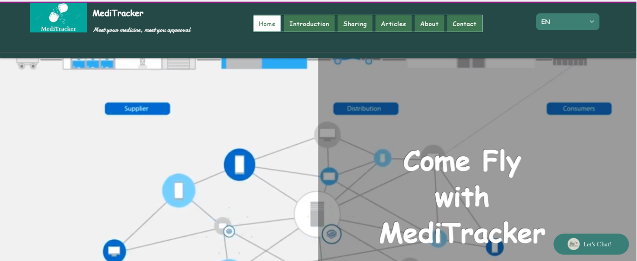

Here is out Homepage for Medi tracker.

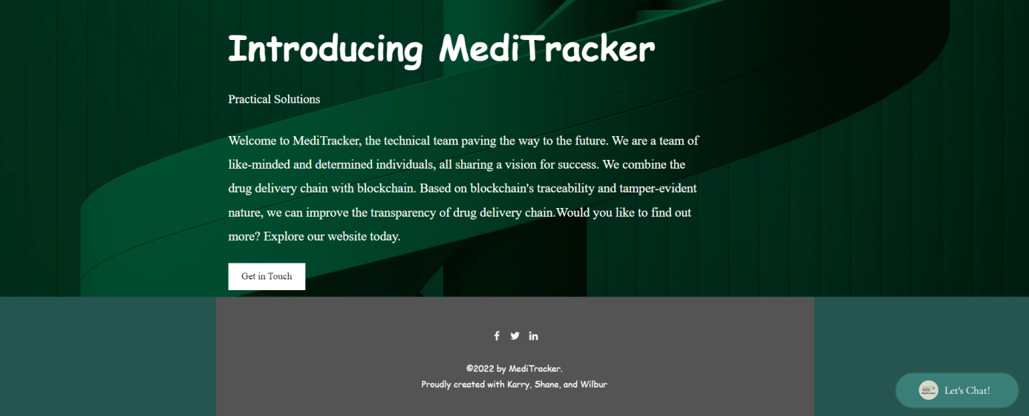

This is a brief introduction of our Medi Tracker and some related materials, and if you want to learn more, just clicking the button: 'Learn more'.

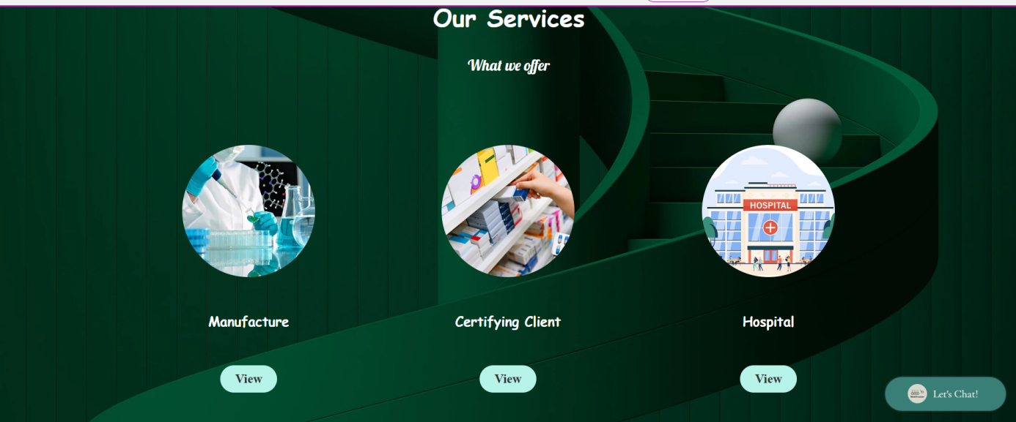

Here are our services for the Meditracker. We provided three components: The manufacturer, the certifying client, the hospital.

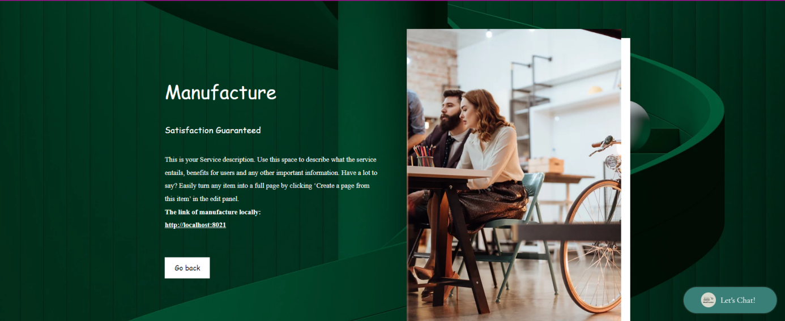

This is the page of the manufacture and click the link below you can enter the manufacturer webpage by your local host.

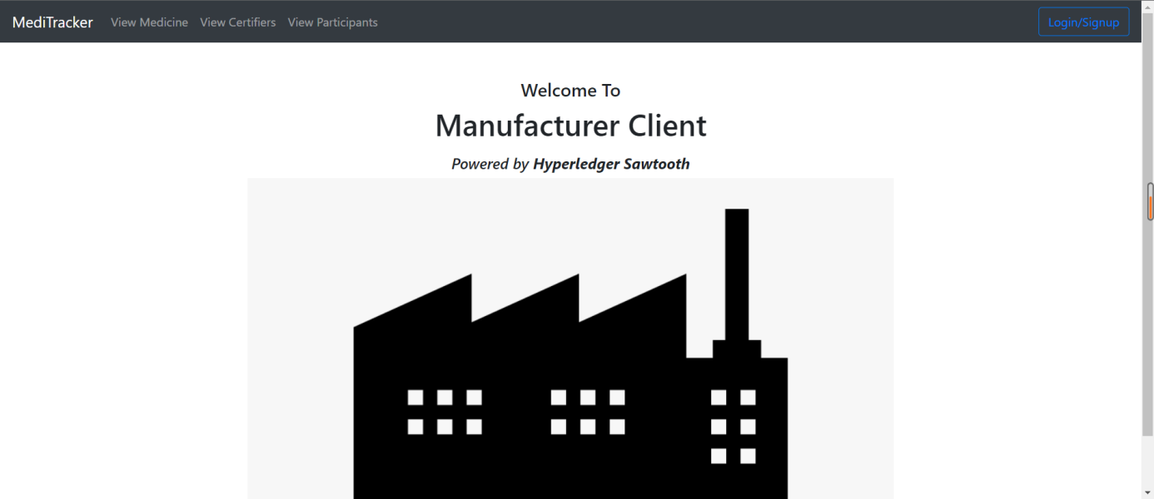

This is our webpage of the manufacturer link with local host, which is more safely to use.

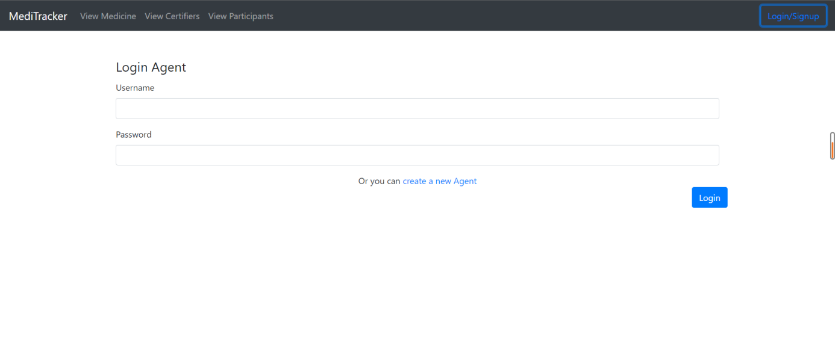

this is the login page for the manufacturer client.

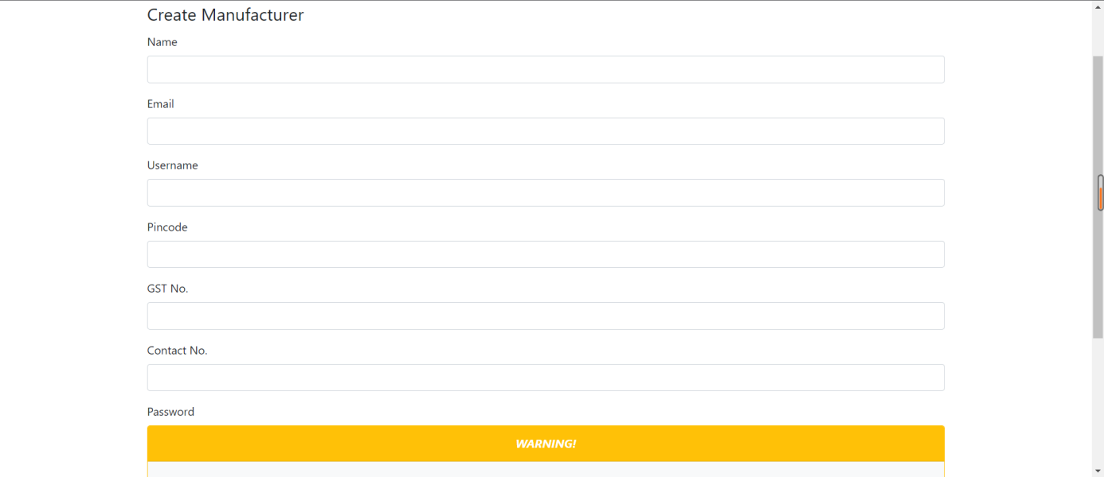

this is the signup page for the manufacture client and the password is hashed.

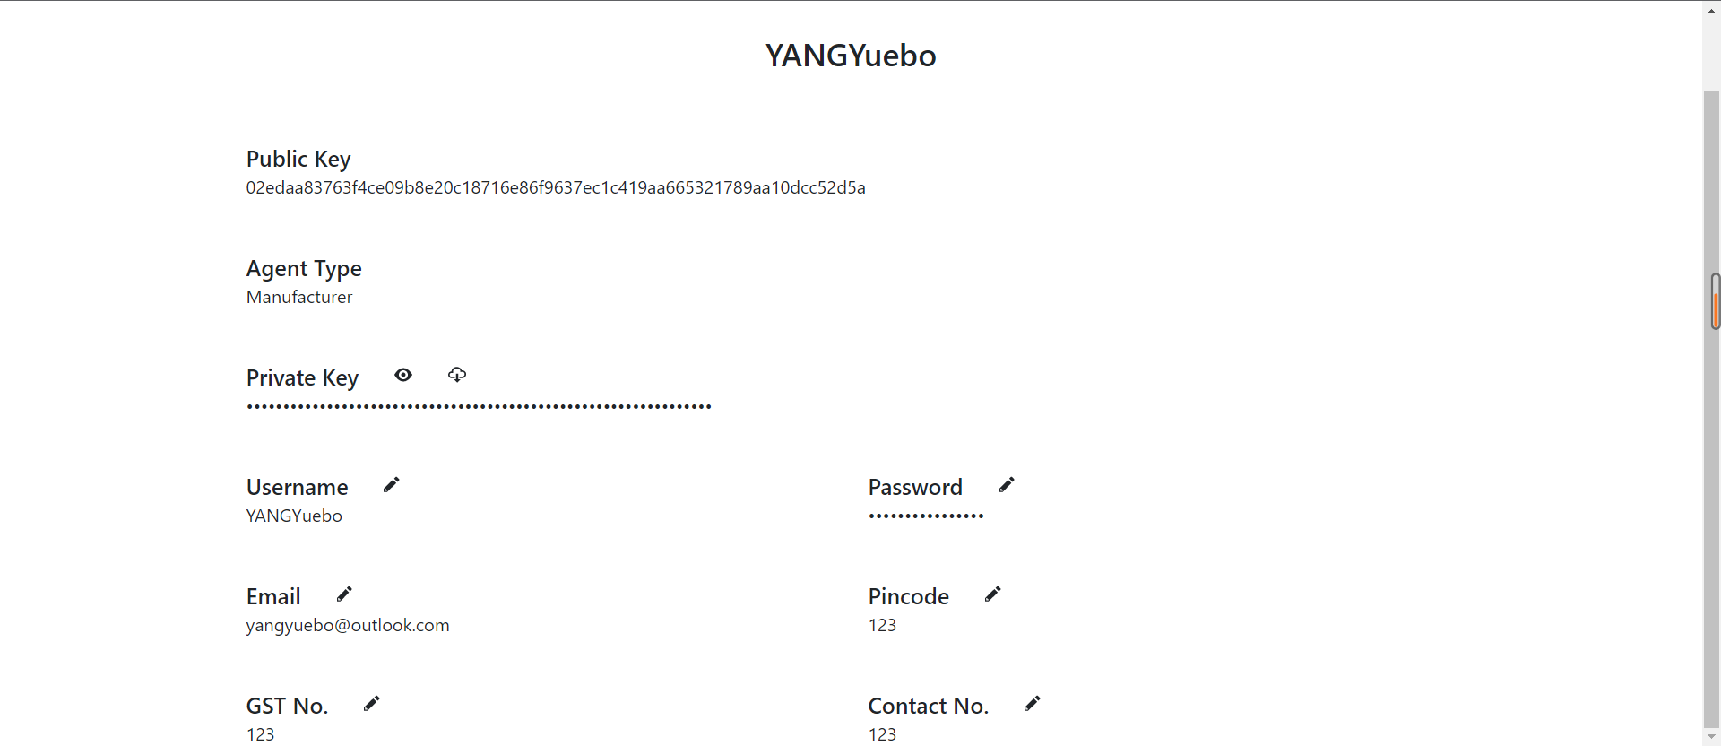

Here is the personal profile of the manufacture client with public key and private key.

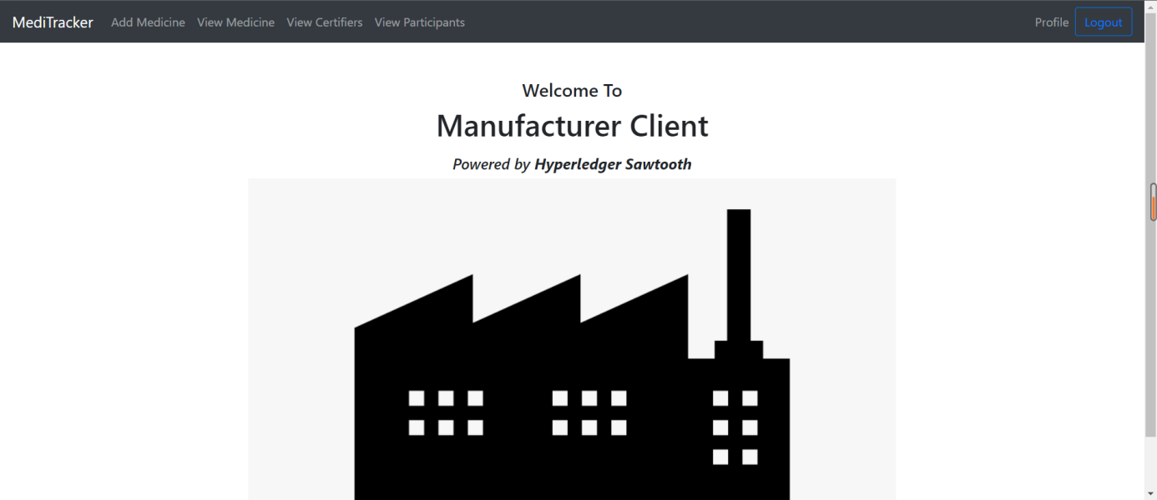

This means that you login successfully.

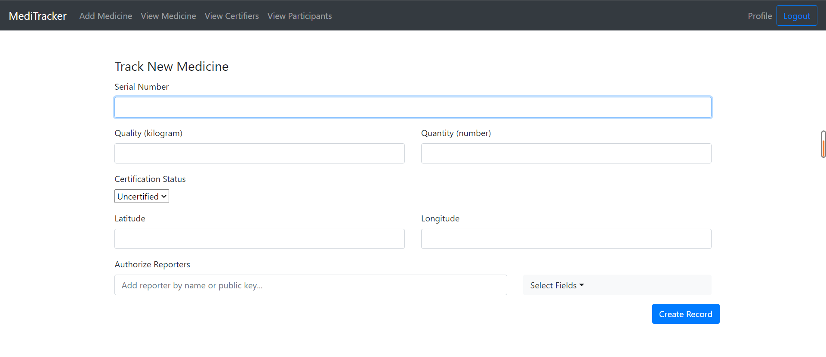

Here the manufacture client can add the medicine, they need to enter the serial number of the drugs, the quality and quantity of the drug, they need to check whether it is verified or not and authorized reporters. Eventually they can create the record.

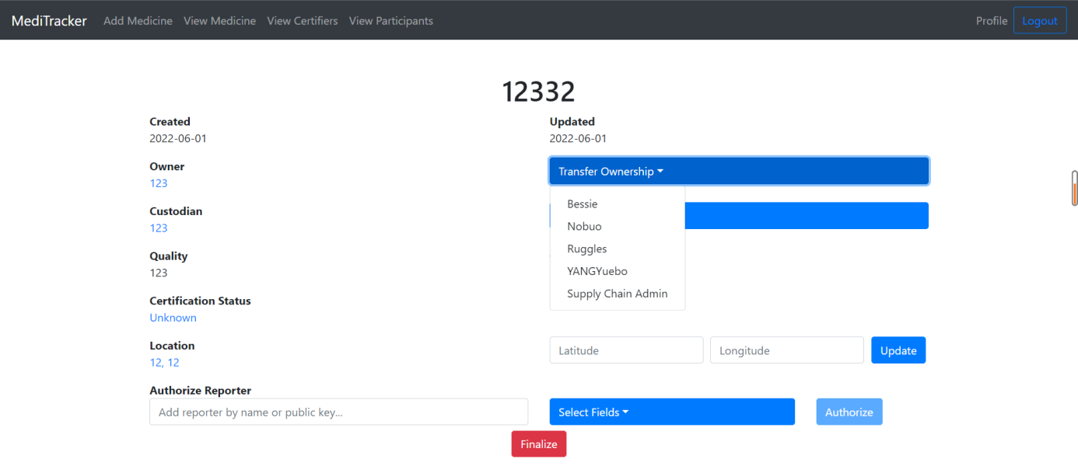

Here is the recode created by the manufactured. The manufactory can also have the permission to transfer the ownership.

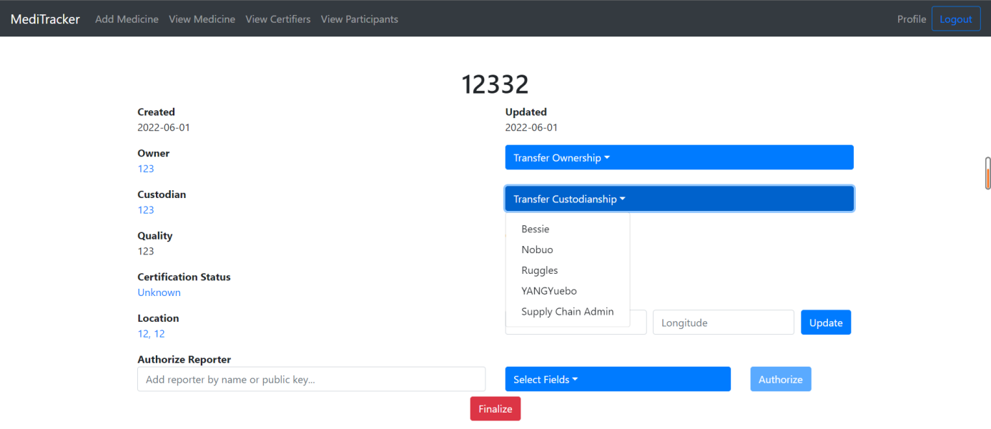

The manufacture has the permission to change the custodianship.

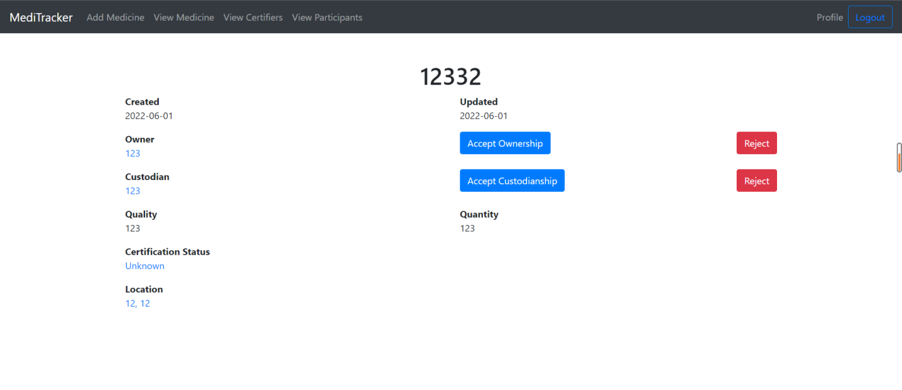

The other client can determine whether he should reject or accept the ownership.

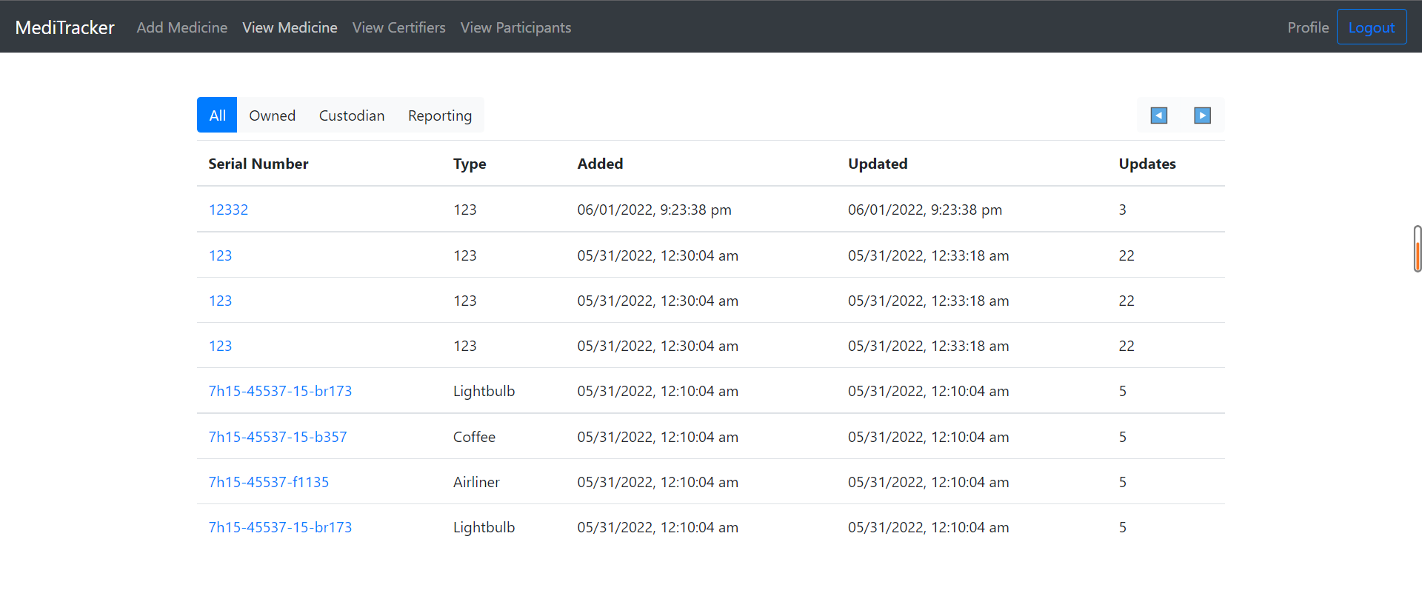

Here is the medicine record of the supply chain. They can check the serial number, the type of medicine, the added time, the updated time, and the times of update, it is quite transparent.

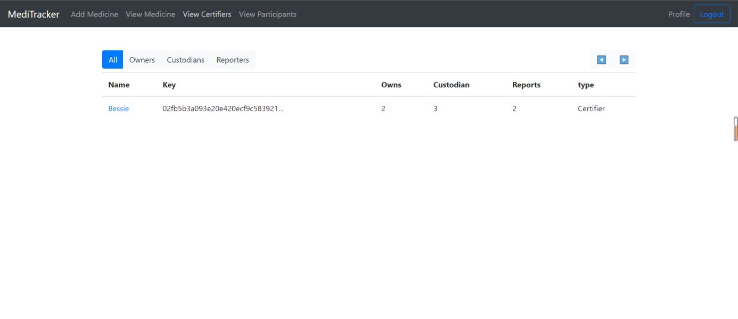

Here the manufacture can view the verifier of the medicine.

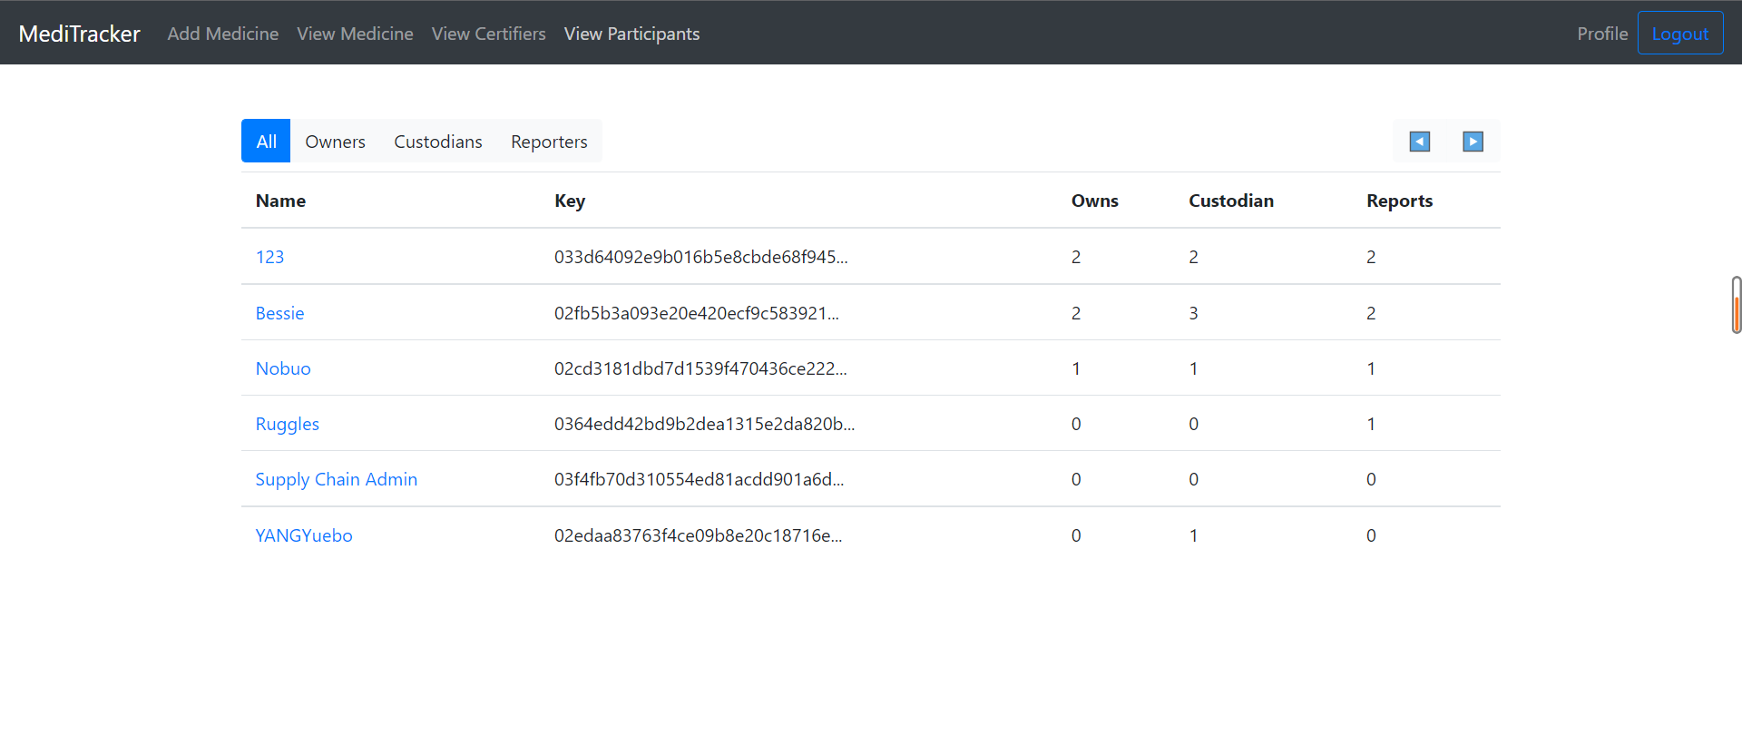

The manufacture can view part of the participants information.



Here is the webpage of certifying client page, too can click the local link to view it.

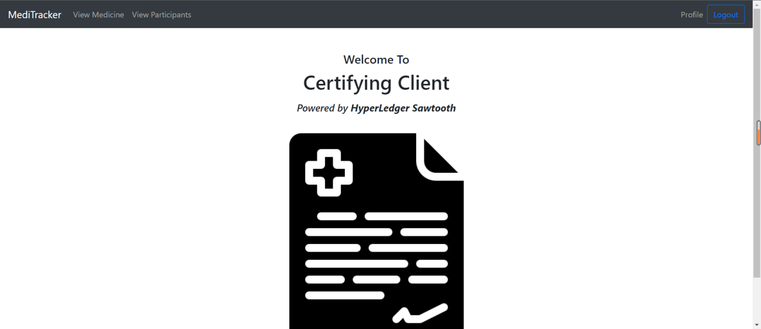

Here is the homepage of the certifying clients, the ones need to login first with their username and password.

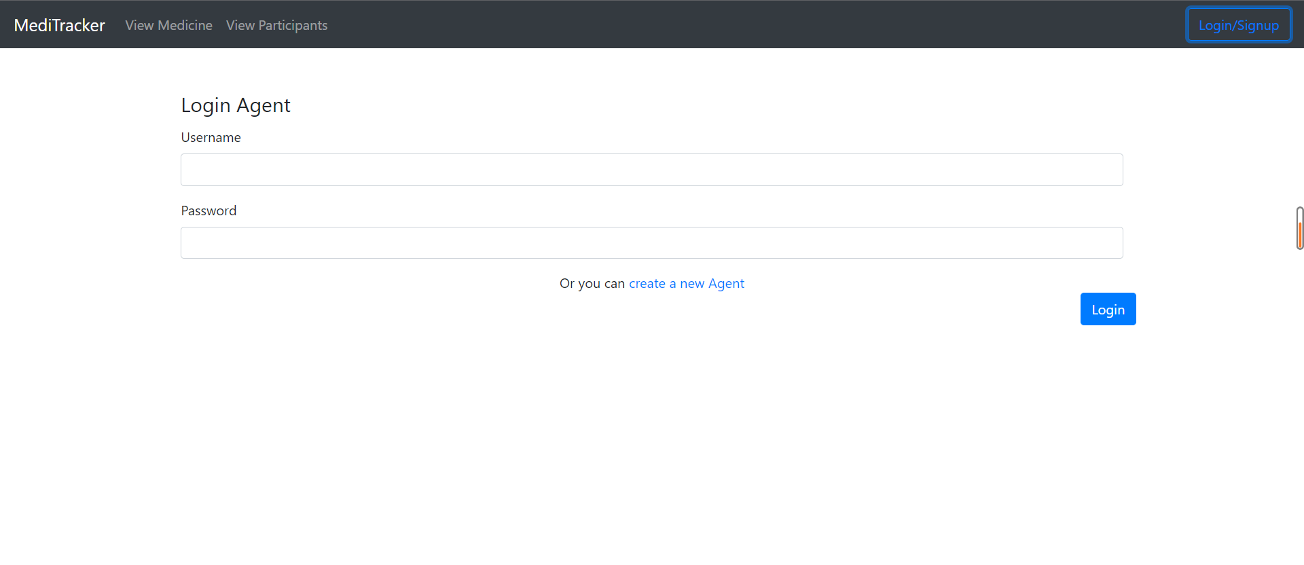

Here is the login page for the certifying client.

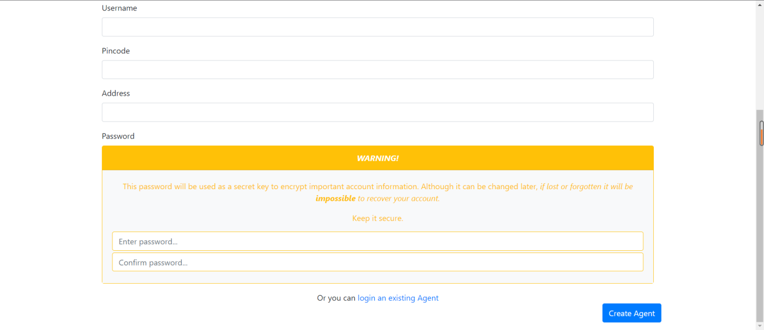

Here is the sign-up page for the certifying clients.

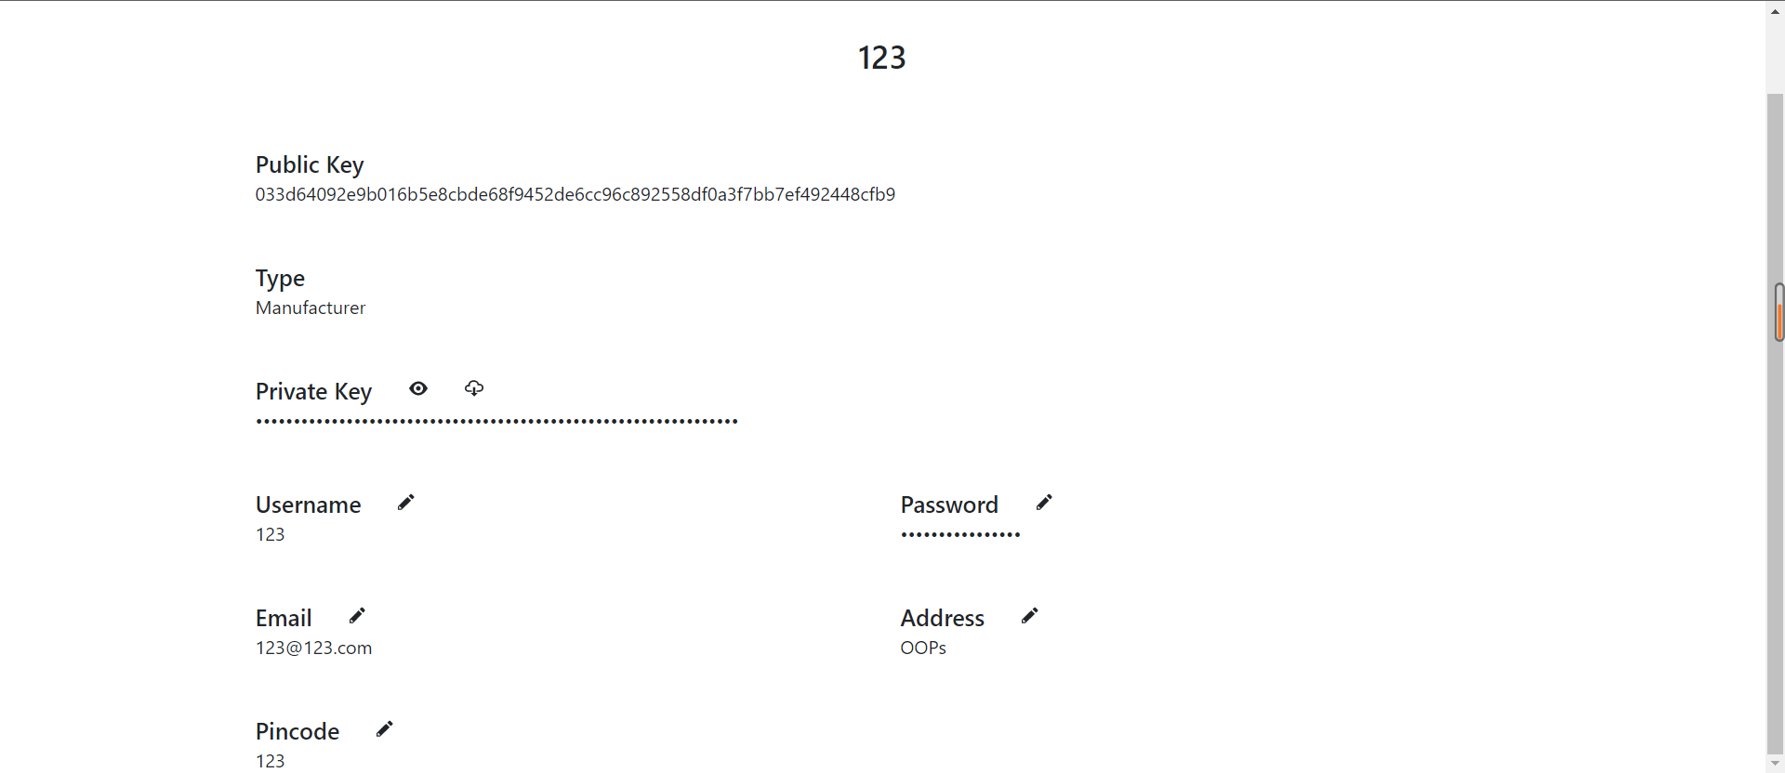

Here is the profile of the certifying client, you can view the public key and the username and the address.

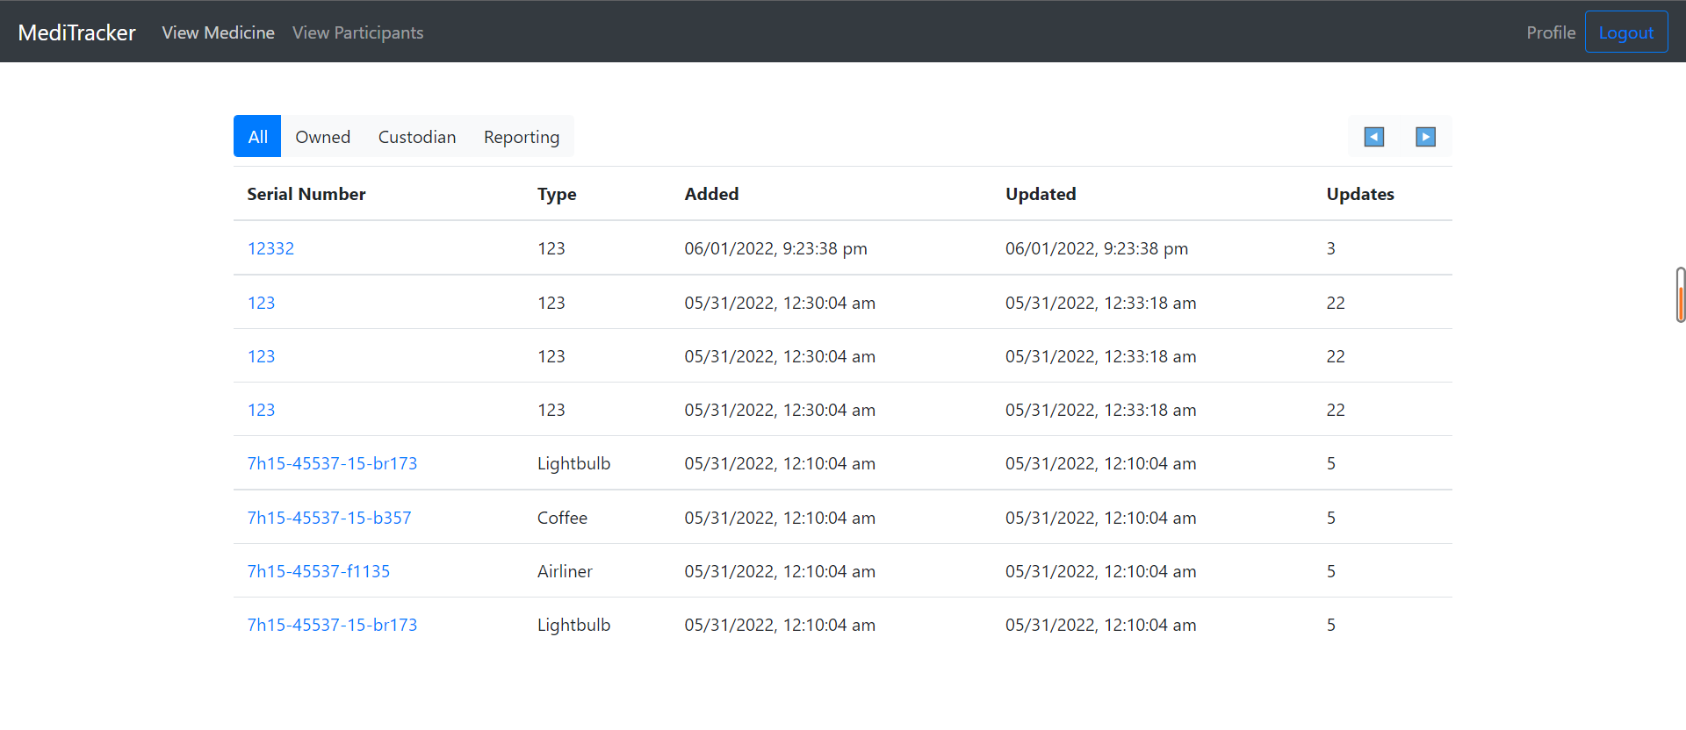

The certifying client can view the message of medicine in the supply chain.

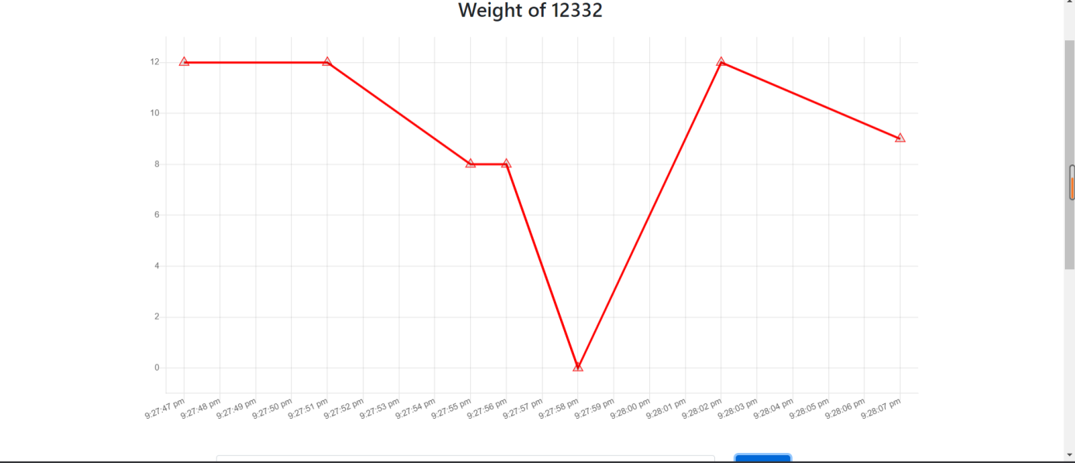

They can update the weight of each medicine.

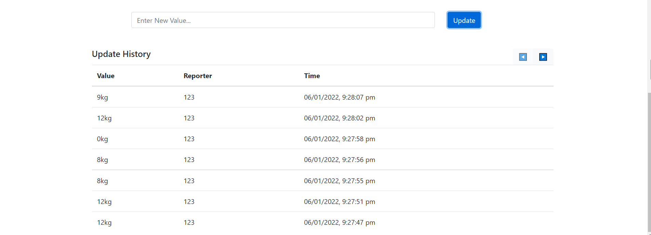

they can even check the record of the change of weight if each medicine with its reporters.

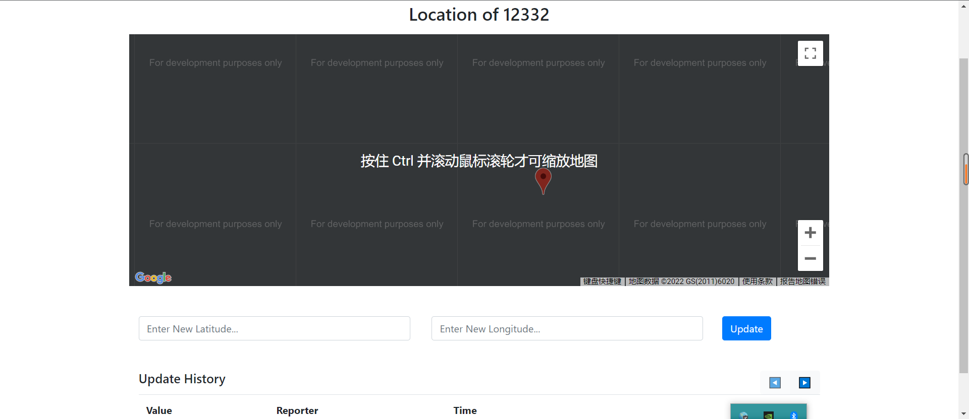

they can also add the location of the medicine, which is sufficient to find it.

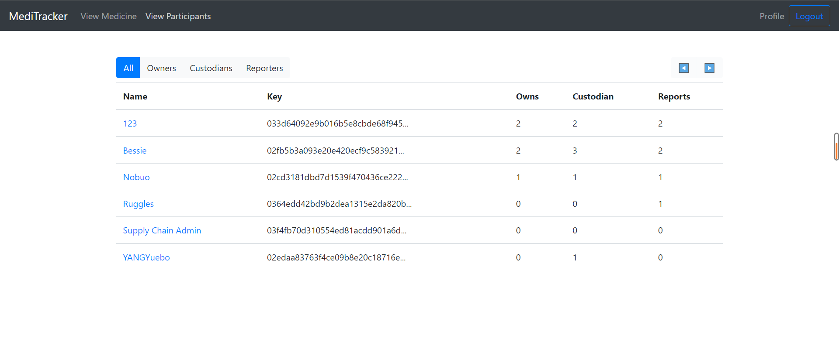

They can view the participants of the platform they can view their username and their public keys.



Here is the webpage of the hospital clients, and you can click on the local link to view it.

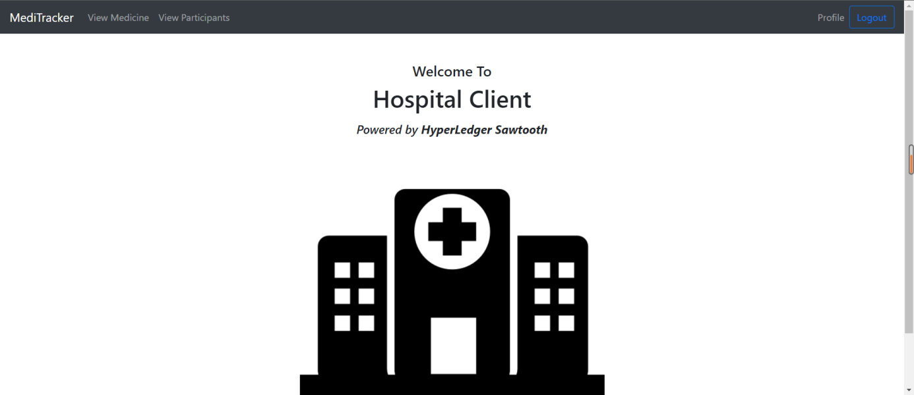



Here is the login page of the hospital clients.

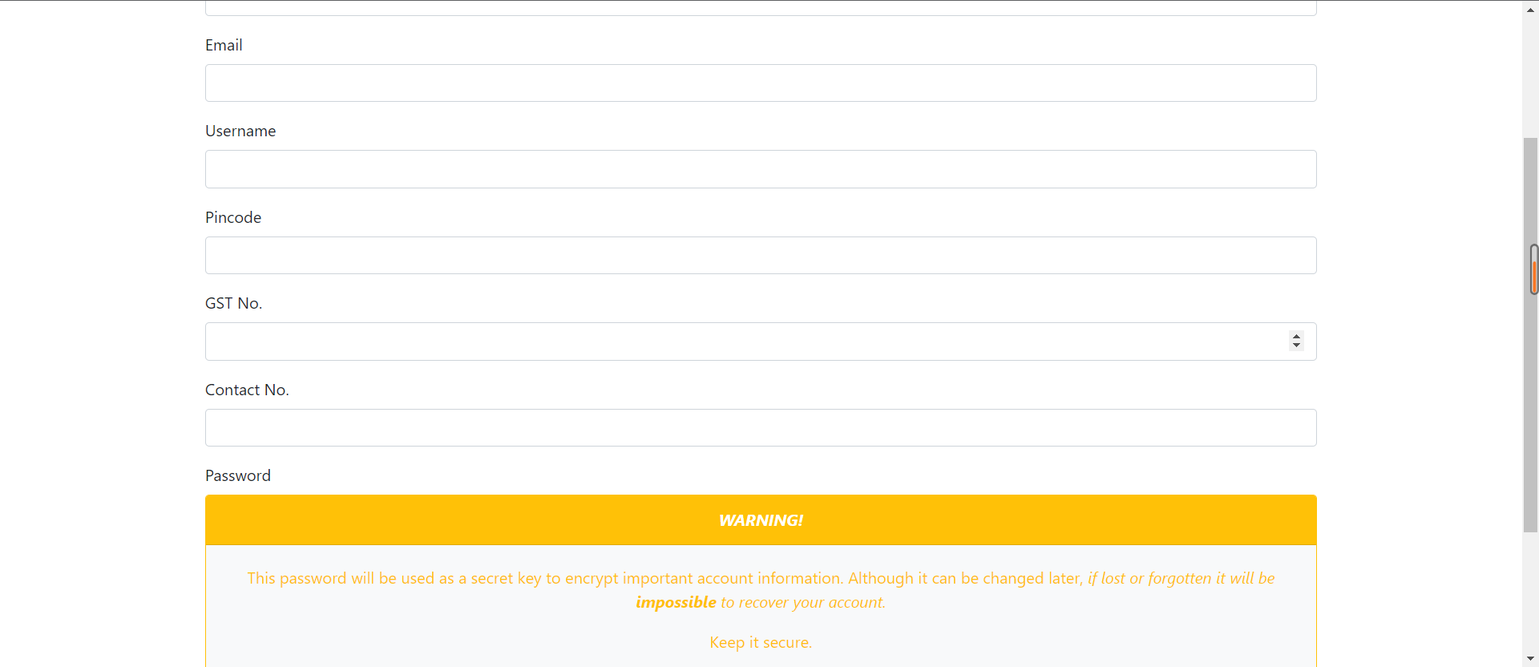

Here is the sign-up page of the hospital clients.

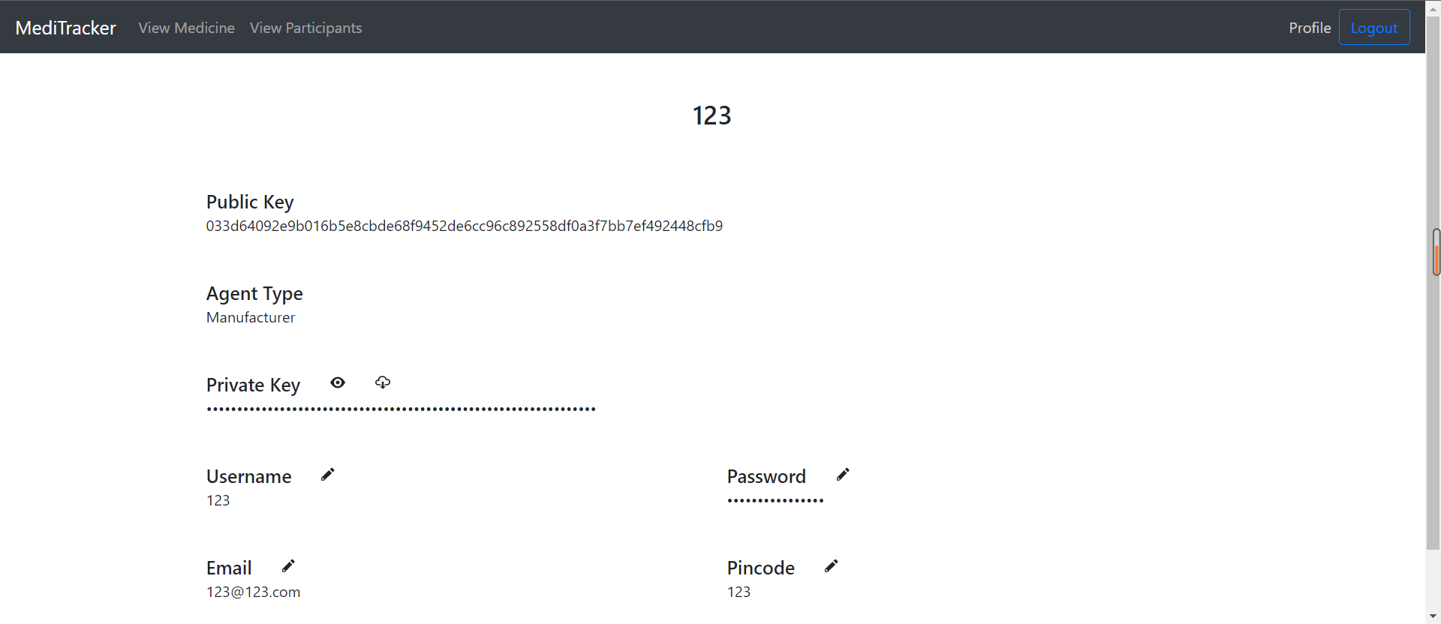

Here is the profile of the hospital clients.

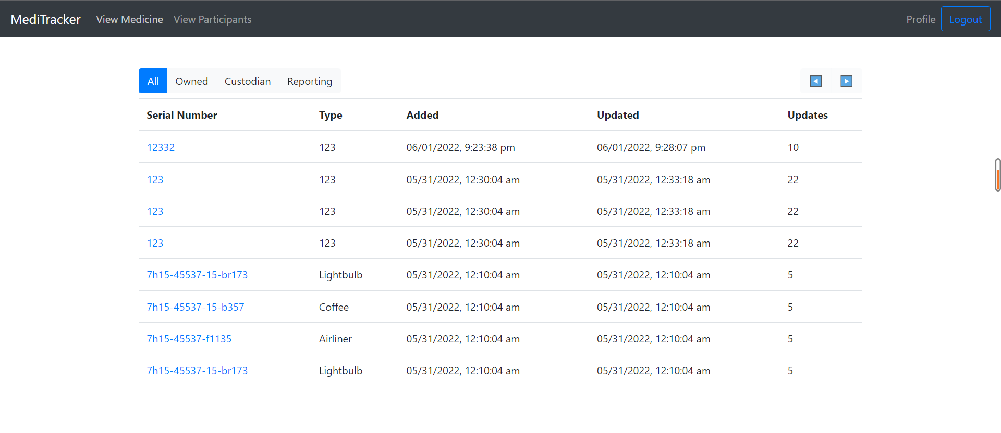

The hospital clients can view some of the information of the drugs.

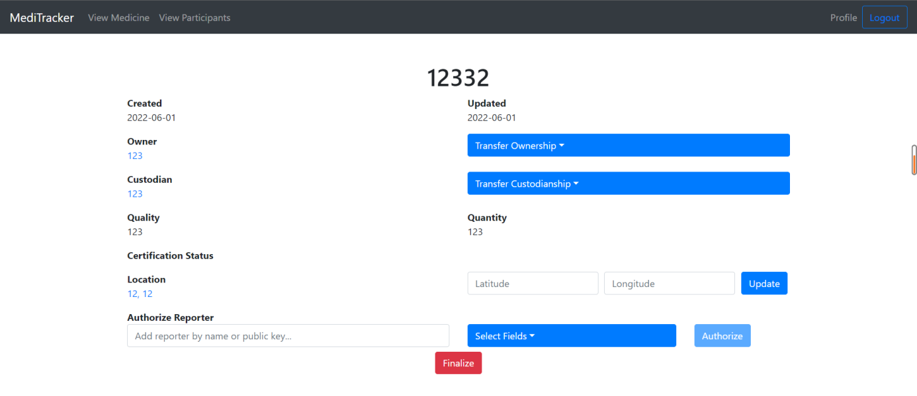

The doctor clients can update the information of the drugs and finalized it.

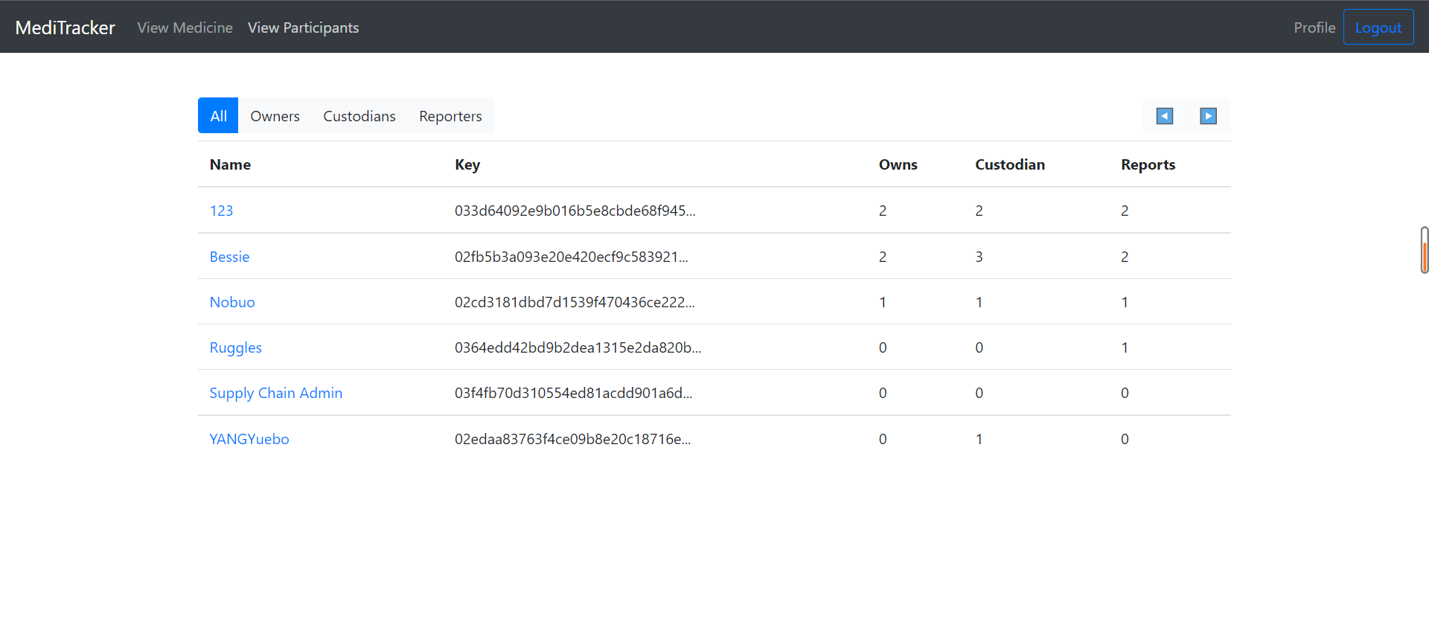

Here the hospital clients can view all the owners, reporters, and custodians in this webpage, they can check their account and their public key.



You can also share our webpage through the instream, which is also a way for us to recommend out project.



Here we provided with some articles about blockchain and medicine, which is offered for you to read.

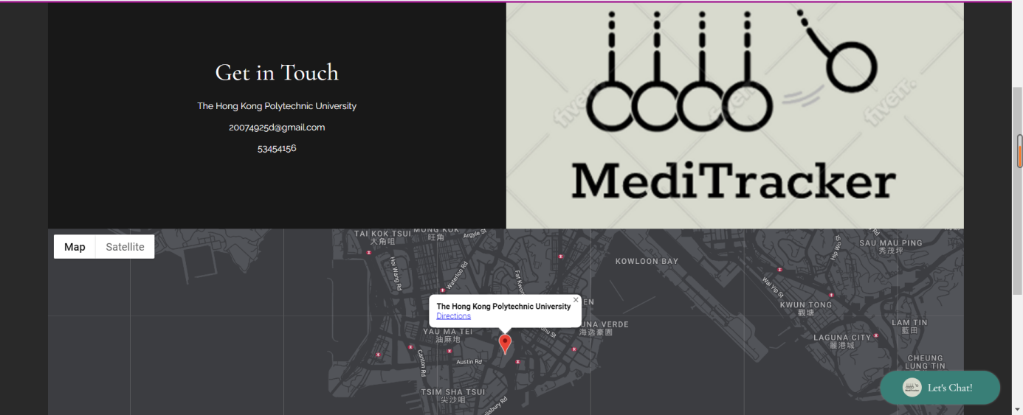

Here is our team information, if you have enquired, feel free to contact at us.

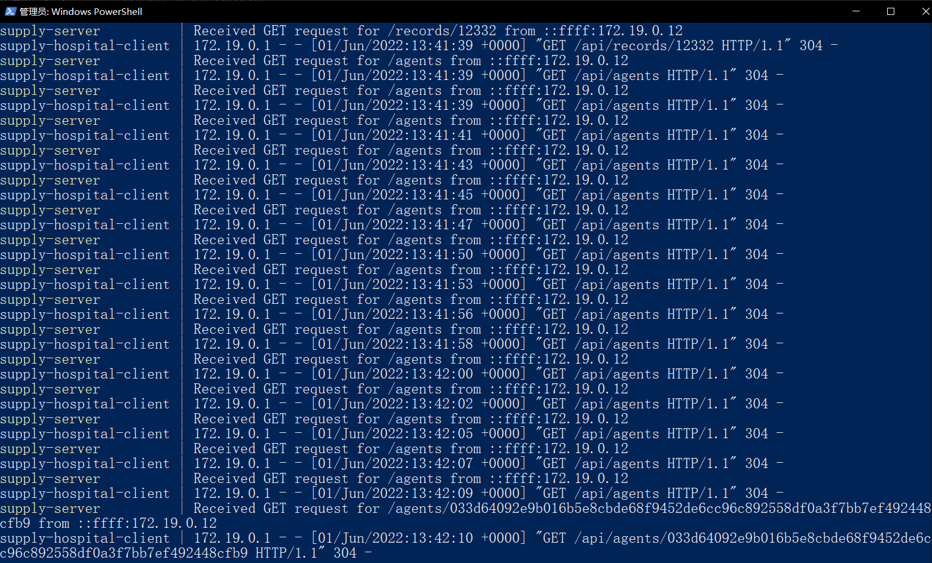

Okay, and know shut down the server and close all the windows of MediTracker.

# Market and Competition

## 6.1 Few Blockchain Implementation

Despite a few developments in distributed investigate on the employments of blockchain within the wellbeing division, the state of play is still juvenile. Most investigate presents novel blockchain systems, designs, or models but technical subtle elements the blockchain components utilized are rarely given and there is rarely any prototype or pilot usage to memorize from (Figure 2). Sending of blockchain innovation in wellbeing at a national scale is uncommon. There are illustrations from a few nations, such as Estonia and Malta, of how blockchain technologies offer valuable highlights such as information security protection and administration of quiet consent. The most promising applications of blockchain within the wellbeing care division are for personality management, dynamic quiet assent, and administration of supply chains for restorative supplies and pharmaceuticals, as discussed below.

Figure 2. Most research papers on blockchain in health care describe proposals, not solutions

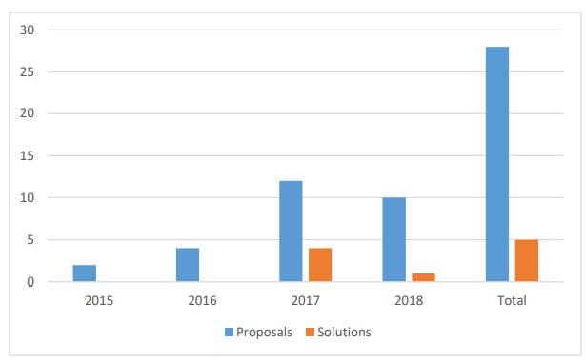

## 6.2 Restraint: Reluctance to disclose data

In the healthcare industry, most healthcare providers, and payers, especially in emerging nations, are reluctant to disclose data due to a lack of regulations related to medical data exchange. For healthcare providers, it is a competitive advantage to keep data to themselves as sharing of data with healthcare payers could reduce the reimbursement as they might get different rates for different patients. In this situation, where all the stakeholders in the healthcare industry are at a profit war with one another and are very reluctant to share the correct data, the implementation of a transparent technology such as a distributed ledger would be a challenge. This is expected to hamper the adoption of blockchain technology in the healthcare sector.

## 6.3 Opportunity: Government Initiatives (Smart City)

The blockchain technology is emerging as a valid solution in the healthcare industry. Many startups have started addressing major pain points in the healthcare industry (such as medical record interoperability, data security, and preventing counterfeit drugs from entering the pharmaceutical supply chain) with the help of the blockchain technology. In the last few years, blockchain technology has drawn the attention of various stakeholders in the healthcare industry. Due to the increased interest in this technology, different government bodies across the globe are investing in blockchain to research the same.

## 6.4 Challenge: Lack of awareness & understanding

The major limitation to the growth of blockchain technology is the lack of knowledge about the distributed ledger technology and its application in the healthcare industry. End users in the healthcare industry lack an understanding of the benefits of this disruptive technology and how it works. This could restrain companies from investing in this evolving technology. In its current form, the blockchain technology is something of a vast, unknown frontier with uncertain growth. Investors, public, and entrepreneurs are yet to leverage its potential for transforming business processes.

Blockchain uses cryptographic algorithms running across a vast network of independent computers. Therefore, sound technical knowledge about the related technology is crucial to explore the benefits of the blockchain. The lack of knowledge and public awareness is one of the biggest restraints to the adoption of blockchain. The increasing adoption and use of the distributed ledger technology would make the understanding of blockchain essential in the coming future. This would lead to the establishment and proliferation of platforms to provide training in this field. However, the challenges of legacy infrastructure would continue to be an obstacle as the practicality of implementing decentralized cryptosystems is beyond the traditional IT development skillset.

# Team

Team Name: SKW Hackers

Team members:

|  |  |  |  |  |
| --- | --- | --- | --- | --- |
| **Name** | **English Name** | **Student ID** | **Department** | **Year** |
| YANG YUEBO | Wilbur | 20074925D | COMP | YEAR 2 |
| XU JIAYING | Karry | 20039762D | COMP | YEAR 2 |
| XIE QICHEN | Shane | 20039884D | IMT | YEAR 2 |

# Projections and Milestones

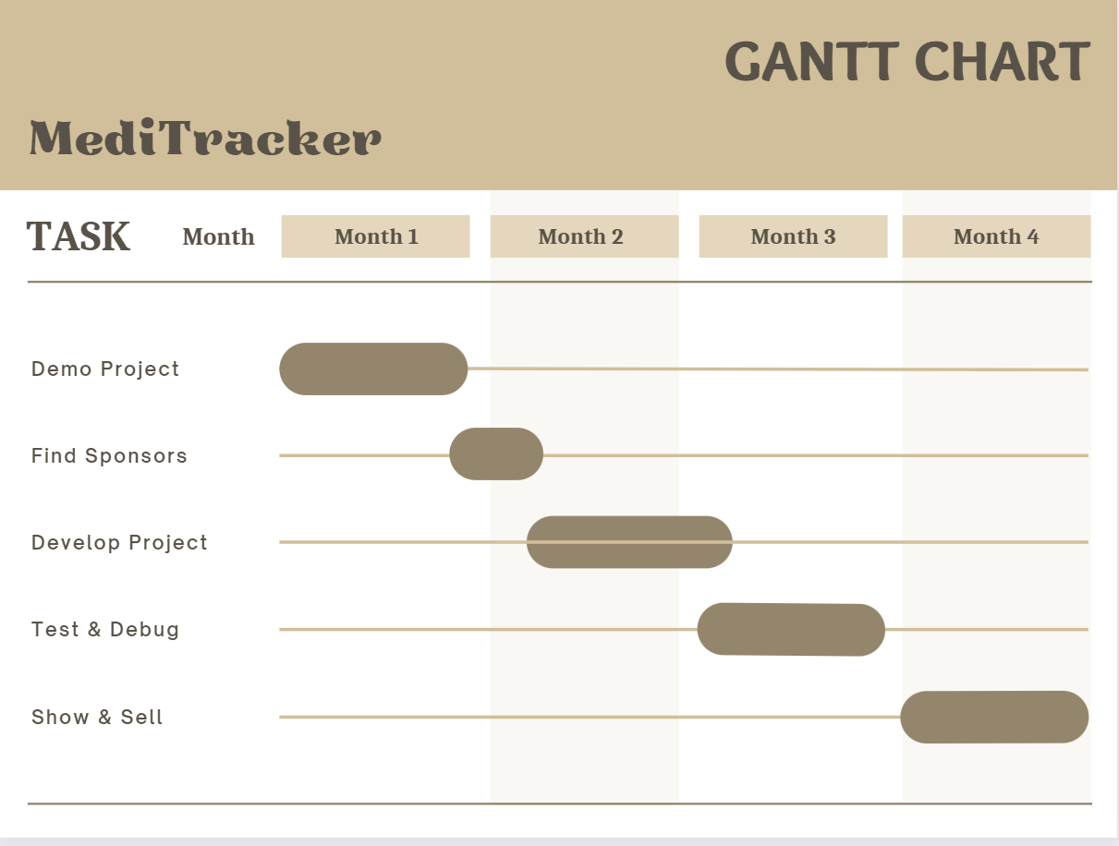

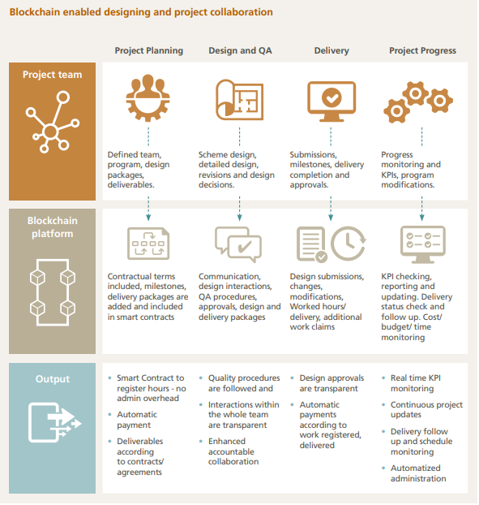

As the plan prepare begins, the stage makes a difference to gather and record each fundamental interaction inside the DJV and/ or between project members. It must be highlighted that within the stage, the distinctive plan bundles, or calculations itself would not be shared, but or the computerized marks, endorsements, and quality affirmation steps of creating that plan. This permits savvy contracts to use these inputs to naturally overhaul venture advance measurements, and, since it could be a tamper-proof framework, the responsibility and traceability of plan endorsements are safeguarded. In expansion, all the related worked hours can be enlisted and shared on the blockchain over the parties, thus there is no require of profitable time and asset expending extra bureaucracy. Savvy contracts can handle this authoritative information and educate each member through the upgraded blockchain ledger.

When a plan is wrapped up, the record control framework can advise the keen contract that a plan bundle has been submitted. The fundamental parties are at that point informed to check the archive and as their ID is enlisted as well on the blockchain with their reliable computerized signature, the record can be marked off. All these intuitive are enlisted on the same blockchain stage, subsequently installments and venture execution degree overhauls can at that point be started by savvy contracts.

The focal points of building up such a collaborative framework can improve how a extend is overseen and observed. It can aid limit misalignments of contracts and empower collective remedial activities within the joint wander. Through the traceable information on the blockchain the advance observing and the precision of fetched, and plan gauges can be expanded considerably.

The same concept can be connected not fair within the plan stage of the venture, but at the construction stage as well. There is no significant contrast, since rather than submitting plan bundles, the distinctive development errands are the deliverables. Taking the development of a bored heap as a case. The group who carries out the work has been enlisted and relegated to the errand. These subtle elements are enlisted on the blockchain in a comparative way at that point the hours went through on location. Amid and after construction of the heap the pre-defined determinations and quality confirmation method got to be taken after, which is administered by the location design, quality controller and the extend supervisor. After their carefully marked endorsement (with their smartphone or a tablet on location) the savvy contract can discharge installments and upgrade the program.

The method is exceptionally comparative to what is in put on a development site today. Nevertheless, since there is a fundamental programmed and unchanging blockchain layer, each errand arrange, endorsement and work completion on location with its relating installment are enrolled and traceable. In this way, the installments can be ceaseless from the venture account and make a straightforward stream of esteem right to the foot of the supply chain.

# Status and Milestones

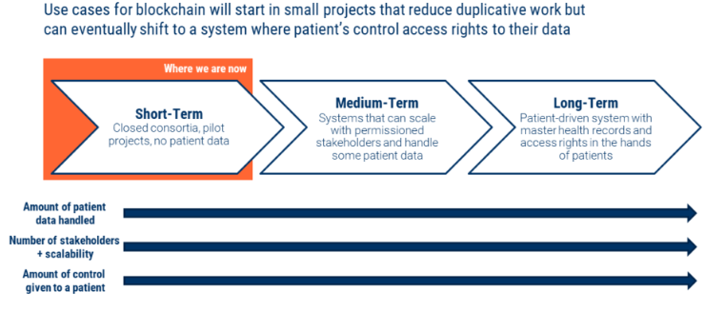

**Short-term applications:**

**Healthcare consultation & managing provider information, Drug supply chain**

These qualities are extraordinary for educate or patients taking care of wellbeing data. Blockchain makes information astuteness harder to alter with and simpler to share between parties is simpler. There are too numerous cybersecurity benefits, counting traceability and the capacity to confirm who has gotten to certain data.

**Healthcare consultation & managing provider information**

Organizations are taking them to begin with steps into blockchain-based ventures by joining little, closed consortia that utilize conveyed record frameworks or permissioned blockchains to keep information among the companies involved. Initial ventures point to prevent duplicated work by sharing information via distributed record frameworks. Nevertheless, none of these ventures’ centers on persistent information since it is so sensitive.

organizations are taking them to begin with steps into blockchain-based ventures by joining little, closed consortia that utilize conveyed record frameworks or permissioned blockchains to keep information among the companies involved. Initial ventures point to prevent duplicated work by sharing information via distributed record frameworks. Nevertheless, none of these ventures’ centers on understanding information since it is so sensitive.

Enterprises are taking them to begin with steps into blockchain-based ventures by joining little, closed consortia that utilize disseminated record frameworks or permissioned blockchains to keep information among the companies involved. Initial ventures point to prevent duplicated work by sharing information via distributed record frameworks. In any case, none of these ventures’ centers on understanding information since it is so sensitive.

**Drug supply chain**

Enterprises are taking them to begin with steps into blockchain-based ventures by joining little, closed consortia that utilize disseminated record frameworks or permissioned blockchains to keep information among the companies involved. Initial ventures point to prevent duplicated work by sharing information via distributed record frameworks. Nevertheless, none of these ventures’ centers on quiet information since it is so sensitive.

Chronicled is propelling a pilot called Medi Ledger with a few huge sedate companies and sedate supply chain mammoths. The venture employments a closed blockchain framework (open for verified members to connect) to track who touched what sedate at what time. By guaranteeing that as it were producers can commission serial numbers and join interesting identifiers to products (which are famous by the record) the framework makes it much more troublesome for a fake item to enter the chain at an irregular point. The blockchain framework system. Framework employments zero-knowledge proofs to allow companies to ensure compliance without really sharing information with each other.

Zero-knowledge verification may be a data-sharing strategy that permits two parties to confirm in case something happened without really uncovering fundamental information to each other. Blockchain-based supply chain frameworks can moreover interface to RFID labels and temperature logging instruments to guarantee that natural necessities were met over the supply chain. On the off chance that the rules are laid out clearly, this framework can execute in a mechanized fashion using keen contracts.

**Medium-term applications:**

**Claims management, payments, & prior authorization, Health information exchanges & research data, Research & trial design**

Medium-term ventures will move past pilots and include more partners. These ventures will start looking at ways to house and share understanding data. It may take longer to execute these ventures since they require participation between more parties and the dangers related with inadvertent quiet information spillage are high.

**Claims management, payments, & prior authorization**

One range where this may be conceivable is in claims administration, where a few agents are centered on standardizing data, taking after complex and variable strategies. Payers got to know what administrations an understanding gotten, and the patients arrange. Specialists ought to know how much to charge an understanding. And everyone wants to know where in its lifecycle a claim as of now is.

Alter Healthcare has built a framework that follows the life cycle of a claim, following each exchange recorded over (information submitted for survey, the audit itself, endorsement, or dissent, etc.). The company has moreover made strides the speed and versatility of preparing exchanges, which has been a bottleneck in numerous open blockchain ventures. Alter Healthcare says it facilitates about 14B exchanges a year between 2,100 payers, 5,500 healing centers, and 33,000 drug stores, among others.

**Health information exchanges & research data**

Information is getting increasingly important — whether to prepare calculations, discover better therapeutics, or get it where clinical trials ought to be set up. This implies existing wellbeing players have an opportunity to monetize their datasets. Right presently, the de-identification of information could be a handle that requires third parties. But as these gotten to be more acknowledged, we will imagine a blockchain-based framework that could facilitate information trade. In expansion, unused directions around how third parties utilize customer information will force companies to create review and assent trails for where the information goes.

**Research & trial design**

Past way better information sharing, blockchain offers an opportunity to move forward healthcare some time recently the treatment stage: in investigate and clinical trials. Viable inquire about and clinical trials require the coordination of different destinations and partners, as well as cautious administration of gigantic sums of touchy information coming from diverse source.

Past way better information sharing, blockchain offers an opportunity to move forward healthcare some time recently the treatment stage: in investigate and clinical trials. Viable inquire about and clinical trials require the coordination of different destinations and partners, as well as cautious administration of gigantic sums of touchy information coming from diverse source

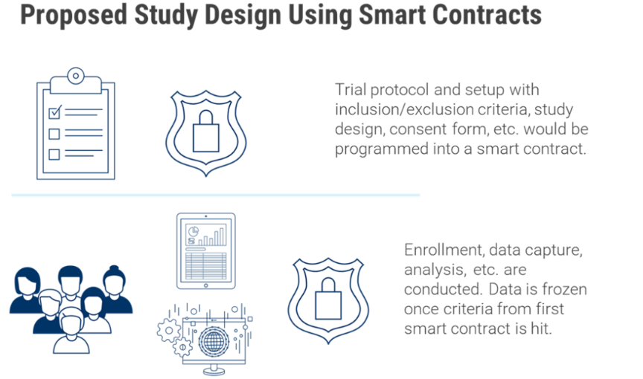

**Long-term applications: Universal identities, patient health records, & dapp services**

The need of interoperability within the healthcare framework could be a gigantic issue, causing duplicative work and a terrible understanding involvement at best and restorative mistakes at most exceedingly bad. An overview from the Pomeron Founded found 86% of restorative blunders were due to quiet misidentification. In the interim a Dark Book study evaluated costs of rehashed care due to copy records at a normal ~$1950 per inpatient and $800 for crisis departments.

The need of interoperability within the healthcare framework could be a gigantic issue, causing duplicative work and a terrible understanding involvement at best and restorative mistakes at most exceedingly bad. An overview from the Pomeron Founded found 86% of restorative blunders were due to quiet misidentification. In the interim a Dark Book study evaluated costs of rehashed care due to copy records at a normal ~$1950 per inpatient and $800 for crisis departments.

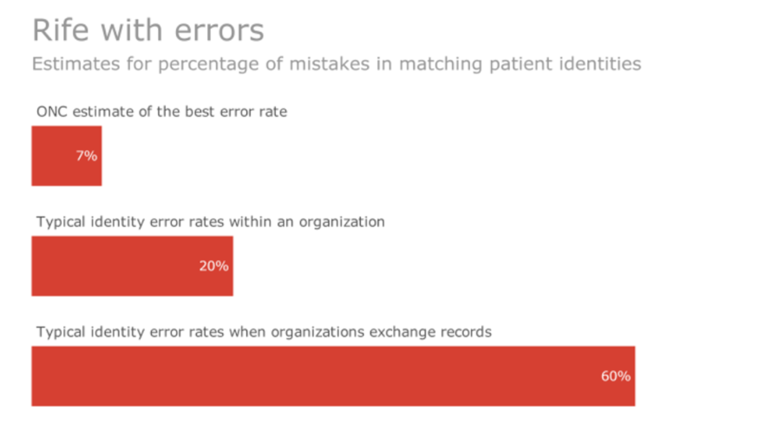

A blockchain record would make review trails of who gotten to a wellbeing record, making more accountability. In expansion, designers have not been able to construct the user-friendly, third-party stages for healthcare that have been progressed in so numerous other segments. But as patients create more information — by means of buyer diagnostics, wearables, genomics, and more — it might be organized and captured into a patient-owned individual wellbeing record. A decentralized understanding wellbeing record framework may better capture information and grant better data get to control to patients. Patients seem allow keys to their information to whoever they need authorized.

his would debilitate any trade demonstrate that is subordinate on accumulating information as a channel. It would too cruel that companies would ought to way better illustrate the kind of esteem they would deliver patients straightforwardly in exchange for their data (as contradicted to buying it from third parties that collect and de-identify the data).

**The road ahead**

Blockchain technology and distributed ledgers have real potential for healthcare. At the same time, blockchain could bring patients to the center of the healthcare ecosystem by giving them the power over one of their most valuable resources — data.

However, understanding where and when it can be useful is key. When looking at solutions, there are several important questions to ask:

1. Can a project be done without a blockchain? Would it work equally as well if it used cash, or another existing technology?
2. Is blockchain a significant improvement from the existing process?
3. What stakeholders need to be involved for a blockchain project to work, and are they properly incentivized to do so in this system?
4. Is there good reason to think this solution would succeed in the market today?

As the environment is built out, there will be progressively more opportunity to deploy blockchain applications. In any case, there are too merits to centralization as well, counting speed, security, and more. Knowing when to prefer centralization vs. decentralization will be key. The healthcare industry can anticipate more blockchain entrants aiming to figure out the adjust between the two. Those that can have the potential to totally change processes, trade models, and information streams in healthcare.

|  |  |  |
| --- | --- | --- |
| **Tasks** | **Description** | **Status** |
| Organize a Team | Form a team that can always complete the project | On Track |
| Demo Project | Write the proposal and report. Then, create a simple project demo, which contains some part of the main functions, but still needs future development. | On Track |
| Find Sponsors | Use the project demo, proposal, and report to find sponsors and get the funds. | Unscheduled |
| Develop Project | Develop the main project. | Scheduled |
| Test & Debug | Test & Debug is very import for the blockchain related project. | Unscheduled |
| Show & sell | After everything is done, we will present and market our projects to targets | Unscheduled |

# Summary and Call to Action

## 10.1 Future limits and call to action

Blockchain technology is embedded in the healthcare industry, where specific challenges are expected to be addressed. The big problem with using this advanced technology for medical facilities is the lack of expertise. Blockchain applications are still in their infancy and more work needs to be done to explore and research the technology. However, it does apply to the obligations of medical associations and regulatory bodies. It is time for the healthcare industry to improve. Blockchain in the healthcare sector will grow in the future. Its medical applications will be improved with this technological innovation as it helps to interpret the results and progress of the treatment process. Blockchain technology is at the heart of validating transactions and transferring information.

Blockchain innovation has various focal points to offer to the restorative industry. The way the internet revolutionized healthcare and presented telemedicine, so also, the blockchain technology is likely to require therapeutic science to the following level within the future, by decreasing the costs of monitoring, configuration, and having a central server for information, and for the organization overseeing the medical data. Utilizing blockchains in clinical settings will radically diminish handling time, because as before long as a quiet enlists in a consider, total collection of information will be accessible at once, due to availability on the disseminated record.

In the coming days, with the consent of the network members, transactions can be validated and recorded using Blockchain technology. Blockchain will provide digital security through patient-level public and private key encryption as the foundation for a new generation of medical information sharing. The technology holds promise for patient record resolution, anti-counterfeiting, improved interoperability, streamlined processes, drug and prescription control, medical and supply chain surveillance. Blockchain in the healthcare sector is seen as a great future performer.

## 10.2 Conclusion

There are innovative uses of Blockchain in healthcare due to inherent encryption and decentralization. It strengthens the security of patient electronic medical records, promotes monetization of medical information, improves interoperability between medical institutions, and helps fight counterfeit drugs. Different medical fields can change with Blockchain technology; In areas like healthcare, digital agreements enabled by smart contracts are among the most important uses of Blockchain. By removing intermediaries from the payment chain, smart contracts reduce costs. The potential of blockchain in healthcare depends significantly on the adoption of relevant innovative technologies within the ecosystem. This includes systematic monitoring, health insurance, drug tracing, and clinical trials. Hospitals can map their services using the Blockchain framework, even across the entire lifecycle, using device tracking. Therefore, blockchain technology can be used to improve the management of patient history, especially follow-up and insurance mediation processes, thereby accelerating clinical actions with data maintenance. optimized. Overall, this technology will dramatically improve and revolutionize the way patients and physicians process, use clinical records, and improve healthcare.